American Journal of Engineering Research (AJER)
e-ISSN : 2320-0847 p-ISSN : 2320-0936
Volume-2 pp-59-63
www.ajer.org

Research Paper Open Access

Modeling of Masonry infills-A review

Catherin Jeselia M., Jayalekshmi B.R., KattaVenkataramana
Department of Civil Engineering, National Institute of Technology Karnataka, India

Abstract: - Masonry infills are built integral of RC frame, and are usually considered as non-structural elements. Studies have shown that masonry infills can increase the stiffness, strength and energy dissipation characteristic of framed structures. However, the ignorance of effect of masonry infills causes several undesirable effects when lateral loads act on structures. Proper modeling of masonry infills is necessary to account for its lateral resistance. Many researchers have proposed different analytical models in considering the effect of infills into account which are broadly classified into two main groups, namely micro-models (local) and macro-models (simplified). This paper deals with different modeling aspects of masonry infills.

Keywords: - Equivalent diagonal strut, failure modes, macro models, masonry infills, micro models.

INTRODUCTION
Masonry infills have a very high initial in-plane lateral stiffness and low deformability. It contributes to significant lateral stiffness, strength, overall ductility and high energy dissipation capacity; however under seismic loading it can also cause some undesirable effects like torsion, short-column effect, soft-storey effect and out-of-plane collapse. Therefore, under seismic loads, the whole lateral force transfer mechanism of the structure changes from a predominant frame action to predominant truss action which is shown in fig 1.a & 1.b.

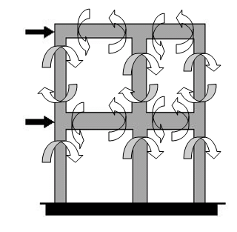 | 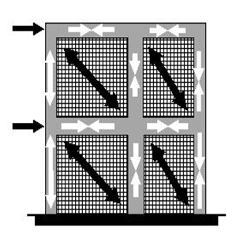
Fig. 1a: Predominant frame action | Fig. 1b: Predominant truss action

FAILURE MODES OF MASONRY INFILLS
Based on both experimental and analytical results during the last five decades different failure modes of masonry in-filled frames were proposed. These are classified into five distinct modes which are shown in fig.2
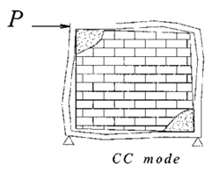  Corner crushing (CC) mode | 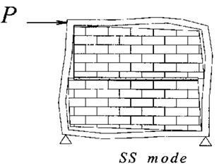  Sliding shear (SS) mode |  | 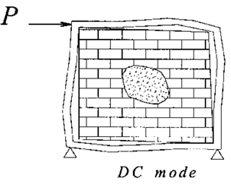  Diagonal compression (DC) mode
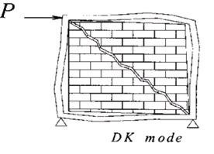  Diagonal cracking mode (DK) |  | 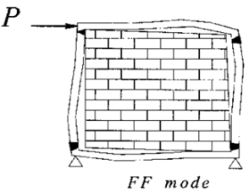  Frame failure mode (FF)
Fig. 2: Various modes of failure (El – Dakhakhni 2003)

Corner crushing mode (CC), represents crushing of the infill in at least one of its loaded corners. Sliding shear (SS) mode represents the horizontal sliding shear failure through bed joints of a masonry infill. Diagonal compression mode (DC), represents crushing of the infill within its central region. A crack is formed across the compressed diagonal of the infill panel in Diagonal cracking (DK) mode. Plastic hinges are developed in the columns or in beam-column junctions, which results in the Frame failure (FF) mode.

MODELING OF MASONRY INFILLS
Micro models
Micro-modeling is a complex method of analysis and it is always done by using finite element method. The benefits of using finite element approach is that, all possible modes of failure i.e., all the local effects are discussed in detail but its use is limited due to the greater computational effort and time-requirement. Mallick and Severn[1] were the first one to use this FEM approach. The interface between frame and infill was modeled by considering frictional shear forces in the contact region using link element. This element was able to transfer compressive forces, but incapable of resisting tensile forces. They identified that the element was able to transfer compressive and bond forces, but incapable of resisting tensile forces. Later two schemes i.e., exact and constrained schemes were suggested by Axely and Barter[2] to find the stiffness of frame infill system. Liauw and Kwan[3] proposed a plastic theory in which three different failure modes were identified, related to the relative strengths of the columns, the beams and the infill. These models captured corner crushing with failure in columns, beams and diagonal crushing of the infill. Dhanasekar [4] considered non-linear isotropic six-node elements for both the mortar and the bricks and have developed a model of brick masonry wall considering bricks and mortar joints separately. Ali et al.[5] proposed a model similar to Dhanasekar but with four-node quadrilateral elements with a fine mesh near the loading point was used.
Asteris et al.[6] used the frame-infill separation criteria to find the geometrical equilibrium condition for the composite structure of the in-filled frame under certain loading conditions. The infill/frame contact lengths and the contact stresses were estimated as an integral part of the solution. Ghosh &Made[7] verified the analytical procedures of the previous authors with the experimental results of a new model which included interface elements at the frame-infill interface. The results obtained showed that the numerical model was not only capable of predicting the load carrying capacities of infilled frames, but could also provide detailed information on the failure mode, ductility, and cracking. Das & Murthy[8]performed a non-linear pushover analysis on five RC frame buildings with brick masonry infill, designed as per Euro code, Nepal Building Code, Indian Codes (IS 456, IS 13920) and by Equivalent Braced Frame (EBF) methods. From the different design procedures as per various codes, the EBF method was found to be very beneficial.

Macro models
Macro-models are the ones in which the masonry infill is replaced by an equivalent pin-jointed diagonal strut system. The basic parameter which affects the stiffness and strength of these struts is their equivalent width which depends on the relative infill-frame stiffness. In the literature since then, a number of macro-models have been proposed by other researchers.
Polyakov [9] was the first in replacing the masonry infills by an equivalent pin-jointed diagonal strut by experimenting it on steel frames. Holmes [10] proposed that the effective width of equivalent strut found to be 1/3rd of the diagonal length of infill panel. Smith [11] studied that the effective width varies from d/4 for a square infill to d/11 for an infill having a side’s ratio of 5 to 1, where‘d’ is the length of the masonry infill. Stafford Smith[12] discussed about the interaction between frame and infill, and developed a set of empirical curves that relate the stiffness parameter to the effective width of an equivalent strut.
By using Smith’s relative stiffness parameter, Mainstone [13] proposed an empirical relation between the effective width of an equivalent strut and Stafford Smith′s stiffness parameter. This relation results in a lower value of effective width of diagonal strut than that given by Stafford Smith′s model. Liauw and Lee[14]extended the study of diagonal strut for the masonry infilled frames with and without openings, and concluded that the position of opening greatly affected the strength and stiffness of the infills. Hendry[15] also presented the equivalent strut width as half the width proposed by Smith. Liauw and Kwanstudied both experimentally and analytically the behaviour of non-integral infilled frames considering the nonlinearities of the material and the structural interface.
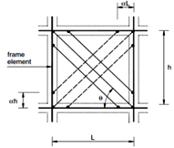 | 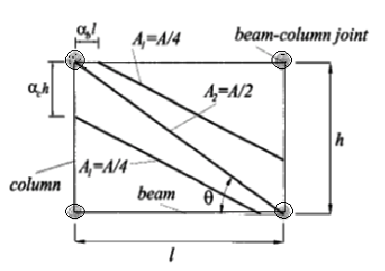
Fig.3a Six-strut model for masonry-infill in frame structures (Chrysostomou 2002) | Fig.3b Proposed masonry infilled steel frame model (El – Dakhakhni 2003)

Paulay and Preistley[16] pointed out that a high value of strut width will result in a stiffer structure, and therefore a higher seismic response. And they proposed the width of diagonal strut as 0.25 times the diagonal length of the strut. Mehrabi et al.[17] had found that Mainstone& Weeks model significantly underestimates the lateral stiffness of the uncracked RC sections. Chrysostomou et al.[18]proposed a model with six compression inclined struts as shown in fig 3.a Three parallel struts in each diagonal direction, and the off-diagonal ones were positioned at critical locations along the frame members. These locations are specified by parameter α, which represents a fraction of the length or height of a panel.

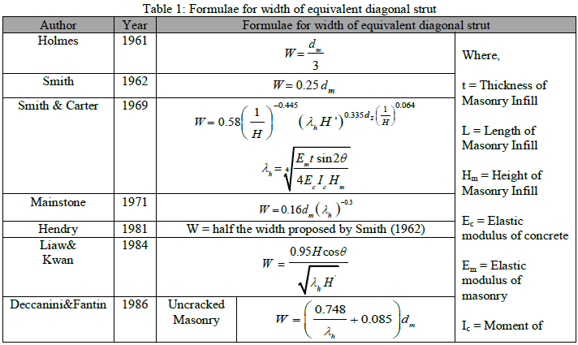

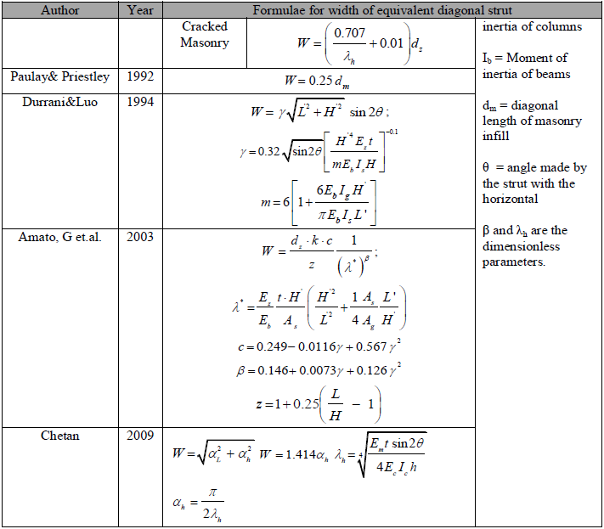

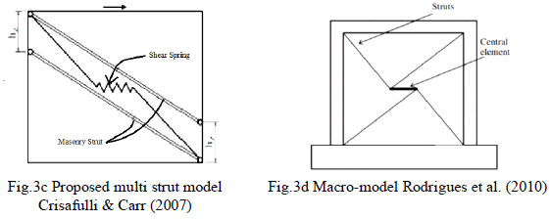
El- Dakhakhni[19] proposed a simple nonlinear macro-model in which each masonry panel was replaced by three struts (one diagonal and two off-diagonal) as shown in fig 3.b. with nonlinear force-deformation characteristics. Crisafulli& Carr [20] proposed a new macro-model for the evaluation of the global response of the structure based on a multi-strut formulation. For compressive and shear behavior of masonry model, four node panel element was implemented and a shear spring in each direction as shown in fig 3.c. Amato et al [21] proposed that equivalent strut, when modeled as a concentric element did not give evidences of the local effects and hence evaluated it eccentrically. The various formulae given by researchers to calculate the width of equivalent diagonal strut is given in table 1. Rodrigues et al.[22] proposed an improved, equivalent bi-diagonal compression strut model with a central strut element as shown in fig. 3.d. Samoila[23] applied the various expressions of width of equivalent diagonal strut given by researchers to a single-bay, single-storey frame for six different modeling possibilities.

CONCLUSIONS
The review of the current practice as applied in modeling of masonry infills has led to the following broad conclusions by various researchers.
- The masonry infills, although do not interfere in the vertical load resisting system for the RC frame structures, they significantly affect the lateral load-resisting system of the same.
- Formulation given by Paulay and Priestley¹⁶ for equivalent diagonal strut is the simplest of all the methods.
- Indian code does not consider the position or amount of infill present in the structure, whereas Euro code gives importance to the masonry in the first storey but the results of the Indian code are better compared to Euro code.

REFERENCES
- D.V.Mallick and R.T Severn, TheBehavior of Infilled Frames under Static Loading, Proc. of ICE, 39(113), 1967, 639-656.
- J.W.Axley and V.V.Bertero, Infill Panels: Their Influence on Seismic Response of Buildings, EERC, University of California, Berkeley, CA, Rep. UCB/EERC-79/28. 1969
- T.C.Liauw and K.H. Kwan, Nonlinear behaviour of non-integral infilled frames, Computers & structures, 18, 1984,551-560.
- M. Dhanasekar and A.W. Page,Influence of brick masonry infill properties on the behavior of infilled frames, Proc. of ICE, Part 2, 1986,593-605.
- S.Sk. Ali and A.W. Page, Finite Element Model for masonry subjected to concentrated loads, The Journal of Structural Engineering, 114(8), 1988, 1761-1784.
- P.G.Asteris,A New Method of Analysis for Masonry Infilled Frames, SEWC 2002, Yokohama, Japan,2002.
- A.K. Ghosh and M.J.Amde, Finite element analysis of Infilled Frames, The Journal of Structural Engineering, 128(7), 2002,881-889.
- D. Das and C.V.R.Murty, Brick masonry infills in seismic design of RC frame buildings: Part - 2 Behavior, The Indian Concrete Journal, 78(7), 2004, 39-44.
- S. V. Polyakov,On the interaction between masonry filler walls and enclosing frame when loaded in plane of the wall, Earthquake Engineering, Earthquake Research Institute, San Francisco, 1960.
- M. Holmes,Steel frames with brick work and concrete infilling”, Proc. ICE, Paper No. 6501, 1961, 473-478.
- B.S. Smith., Lateral Stiffness of Infilled Frames, Journal of Structural Division, Proc. of ASCE, 114, 1962, 183-199.
- B.S. Smith and C. Carter, A Method of Analysis for Infilled Frames, Proc. ICE, 44, 1969, 31-48.
- R.J. Mainstone, On the stiffness and strength of infilled frames,” Proc. of the ICE, 1971, 57-90.
- T.C. Liauw and S.W. Lee, On the behaviour and analysis of multi-storey infilled frames subject to lateral loads, Proc. of the ICE, Part 2, 1977,641- 656.
- A.W. Hendry, Structural brickwork, Macmillan, London, 1981.
- T.Paulay and M.J.N. Priestley, Seismic Design of Concrete and Masonry Buildings, John Wiley & Sons Inc., New York, USA, 1992.
- A.B.Mehrabi, P.B.Shing, M. Schuller, and J. Noland, Experimental evaluation of masonry-infilled RC frames, Journal of Structural Engineerin., 122(3), 1996,228-237.
- C.Z.Chrysostomou, P.Gergely, and J.F. Abel, A Six-Strut Model for Nonlinear Dynamic Analysis of Steel Infilled Frames, International Journal of Structural Stability and Dynamics, 2(3), 2002, 335-353.
- W.W. El-Dakhakhni, M.Elgaaly, and A. A. Hamid, Three-Strut Model for Concrete Masonry-Infilled Steel Frames, Journal of Structural Engineering, 129(2), 2003,177–185.
- F.J. Crisafulli, and A.J. Carr, Proposed Macro-Model for the Analysis of Infilled Frame Structures, Bulletin of the New Zealand Society for Earthquake Engineering, 40(2), 2007, 69-77.
- G. Amato, M. Fossetti, L.Cavaleri, M.Papia, An Updated Model of Equivalent Diagonal Strut for Infill Panels, Euro code 8, Perspectives from the Italian Standpoint Workshop, 2009,119-128.
- H. Rodrigues, V. Humberto, and A.B. Costa, Simplified Macro-Model for Infill Masonry Panels, Journal of Earthquake Engineering, 14, 2010, 390–416.
- D. Samoila, Analytical Modeling of Masonry Infills, Civil Engineering & Architecture, 55(2), 2012, 127–136.

