American Journal of Engineering Research (AJER)
e-ISSN : 2320-0847 p-ISSN : 2320-0936
Volume-2 pp-53-58
www.ajer.org

Research Paper Open Access

Soil-Structure interaction effects on seismic response of a 16 storey RC framed building with shear wall

Chinmayi H.K., Jayalekshmi B.R.
Department of Civil Engineering, National Institute of Technology Karnataka, India

Abstract: - During earthquake the behavior of any structure is influenced not only by the response of the superstructure, but also by the response of the soil beneath. Structural failures in past have shown the significance of soil-structure interaction (SSI) effects. The present study focuses on SSI analysis of a symmetric 16 story RC frame shear wall building over raft foundation subjected to seismic loading. The transient analysis of structure-soil-foundation system is carried out using LS-DYNA software. Earthquake motion in time domain corresponding to zone III of IS 1893:2002 design spectrum is used to excite the finite element model of soil-structure system. For integrating the SSI effect, four types of soils based on shear wave velocity are considered. Responses in terms of variation in natural period, base shear and deflection obtained from the analysis of the SSI model are compared with that obtained from conventional method assuming rigidity at the base of the structure. The results show that the SSI effects are significant in altering the seismic response.

Keywords: - Natural frequency, shear wall, soil flexibility, soil-structure interaction, time history analysis.

INTRODUCTION
The interaction amid the structure, foundation and soil medium beneath the foundation vary the real seismic behavior of the structure considerably as found by the consideration of the structure alone. The process in which independent response of the soil and structure influences each other is referred to as Soil-Structure Interaction (SSI). Implication of soil-structure interaction effects helps the designer to assess the inertial forces and real displacements of the soil-foundation structure system exactly under the influence of free field motion.
The effects of soil flexibility are mostly ignored in seismic design of buildings leading to unnecessarily costly or unsafe design. The design in general is carried out based on the results of dynamic analysis considering fixed-base condition of structure. Studies on, influence of soil flexibility beneath the foundation carried out by Bielak[1]and Stewart et al.[2-3] showed the reduction in overall stiffness of the building resulting in an increase of natural period of the system. Such lengthening of natural period considerably alters the seismic response of the buildings. Thus the interaction between the structure and the soil needs to be modeled accurately in order to design earthquake resistant structures correctly. The possible severities of neglecting the effects of SSI are foregrounded in previous research works by Mylonakis et al. [4] and Roy and Dutta [5-6].
Present study considers a 16 storey building symmetric in plan with raft foundation resting on varying soil types. Shear walls are placed symmetrically in the external frames. To study the influence of varying soil types, building has been modeled by four alternate approaches, namely, (1) bare frame with fixed supports, (2) bare frame with supports accounting for soil-flexibility, (3) frame-shear wall with fixed supports and (4) frame-shear wall with supports accounting for soil-flexibility. Transient analysis of soil- structure system has been carried out for earthquake motion corresponding to zone III of IS 1893[7] design spectrum. An attempt has been made to find the variation in natural period, base shear and deflections of structure by incorporating soil flexibility as compared to structures with conventional fixed base.

IDEALIZATION OF THE SYSTEM
Structural Idealization
To study the dynamic behavior while accounting the effect of soil-structure interaction, building frame of 16 stories with and without shear wall was idealized as 3D space frames utilizing standard two nodded beam element with three longitudinal and three rotational degrees of freedom at each node. Slabs at different story level, shear wall and the slabs of raft foundation were modeled with four-nodded plate elements with consideration of adequate thickness. The story height as well as length of each bay of all the building frames was chosen as 3m and 4m respectively which is reasonable for domestic or small office buildings. The dimensions of components of the buildings were arrived on the basis of the design following the respective Indian code for design of reinforced concrete structures IS 13920:1993[8] andIS 456 [9]. The thickness of floor slab and roof slab were taken as 0.15m and shear wall as 0.25m. The dimensions of beam were considered as 0.23X0.23m and column as 0.60mX0.60m up to 3 stories and 0.50m X 0.50m over 3 stories. Slab thickness of raft was taken as 0.3m.The materials considered for design of the elements were M20 concrete and Fe 415 steel. The mass density and Poisson’s ratio of reinforced concrete was taken as 25 kN/m³ and 0.15 respectively.
The plan of a typical 3 bay x 3 bay frame and locations of shear wall in the building are represented schematically in Fig.1a and Fig. 1b respectively.
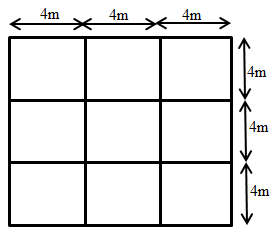 | 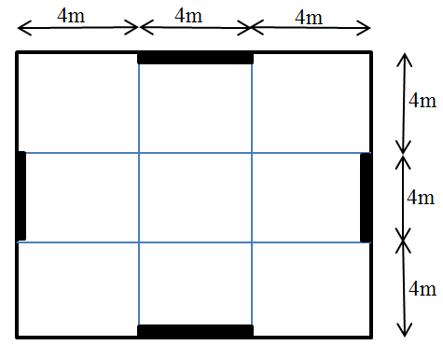
Fig.1(a) Plan of building | Fig.1(b) Location of shear wall
Soil Idealization
To examine the structure-foundation- soil system, soil is treated as a homogenous, isotropic and elastic half space medium. The inputs considered for the linear analysis of structure are density of soil, Young’s modulus (Es) and Poisson’s ratio (μ). The soil medium beneath the raft was modeled employing the eight-node brick element having three translation degrees of freedom at each node. The width and the thickness of the soil medium were taken as 1.5 times and 2 times the least width of the raft foundation (Maharaj etal.[10]) which shows a negligible influence on the settlement and the contact pressure. All translations were restricted at the bottom boundary at bed rock level. The lateral vertical soil boundaries were modelled as non-reflecting boundaries. Fine meshes with aspect ratio 1.0 were generated close to the raft while meshes generated away from the raft were made coarser gradually.
The study primarily attempts to see the effect of soil–structure interaction on buildings resting on different types of non-cohesive soil, viz., soft, stiff, dense soil and rock. The details of different soil parameters are as tabulated in Table 1.

Table 1: Details of soil parameters considered (FEMA 273:1997[11] and FEMA 356:2000[12])
Soil profile type | Description | Shear wave velocity (Vs) (m/sec) | Poisson’s ratio | Unit weight  (ρ) (kN/m³)
Sb | Rock | 1200 | 0.3 | 22
Sc | Dense soil | 600 | 0.3 | 20
Sd | Stiff soil | 300 | 0.35 | 18
Se | Soft soil | 150 | 0.4 | 16

The modelling of the structure-raft-soil system was generated using the LS DYNA software and is as shown in Fig.2
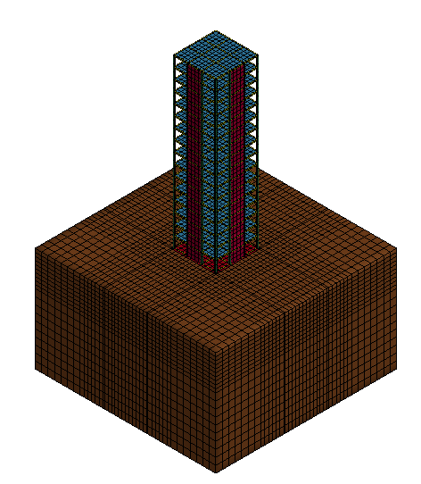
Fig.2 Thee dimensional finite element model of Structure-raft-soil system

METHODOLOGY
The present study adopts the time history analysis which is the most accurate method available to get the seismic response of a structure. In this method, structure’s response history is evaluated by subjecting it to a ground motion corresponding to the zone III of IS code 1893design spectrum with peak ground acceleration of 0.09g. The duration of the earthquake is 30 seconds. Time history of acceleration was applied in the global X direction of the entire soil-structure model. Acceleration time history and associated Fourier spectrum of this ground motion are shown in Figs. 3a & 3b.The analysis was carried out for each incremental time interval and at each stagestructural response was evaluated. LS DYNA explicit dynamic analysis finite element software was used for the time history analysis.
The material damping ratio was assumed as 5% for structure, raft foundations and 7% for soil in the present study from the complying considerations such as, it is sensible to consider 5% of the critical damping for concrete structures and for soil it is based on the guidelines prescribed by Gazetas[13]and numerous analyses suggested by Veletsos and Meek [14].

Fig. 3(a)Acceleration time history of ground motion for zone III
Fig. 3(b) Fourier spectrum curve of ground motion for zone III

RESULTS AND DISCUSSIONS
Following section presents the change in lateral natural period, top deflection and base shear of three dimensional finite element model of integrated soil-raft foundation-RC building accounting the effect of soil–structure interaction. The results are shown in the form of percentage variation, regarding the effect of soil-flexibility with that of the fixed base condition.

Lateral natural period
The modification in fundamental lateral natural period due to the effect of soil–structure interaction was studied on a building of 16 story over raft foundation resting on various soil types viz. Sb, Sc, Sd and Se. The percentage variation in lateral natural period with and without shear walls incorporating soil stiffness as compared to fixed base condition is as tabulated in table 2

Table 2: Percentage variation in lateral natural period of building
Building type | Soil type | Natural period (sec) |  | % variation in natural period
 |  | Without  SSI | With  SSI | due to soil | due to shear wall | due to soil and shear wall
Bare frame | Sb | 3.00 | 3.51 | 16.87 | - | -
 | Sc |  | 3.52 | 17.17
 | Sd |  | 3.55 | 18.28
 | Se |  | 3.66 | 22.08
Shear wall | Sb | 1.58 | 1.64 | 3.63 | -53.30 | -45.43
 | Sc |  | 1.73 | 9.43 | -50.82 | -42.37
 | Sd |  | 1.98 | 25.04 | -44.33 | -34.15
 | Se |  | 2.41 | 52.58 | -34.18 | -19.65

From table 2 it is observed that, the inclusion of soil flexibility in buildings increases the value of natural period. It is observed to be maximum in soft soil (Se) and minimum in hard soil (Sb). The values of natural period obtained in shear wall building is lower when compared to bare frame building due to the increase in stiffness of the building by the addition of shear wall. The maximum reduction of 53.3% is observed due to the inclusion of shear wall in Sb soil type and minimum variation of 34.18% in Se soil type. However, the values of natural period obtained by considering the combined effect of soil and shear wall shows that the effect of soil flexibility in increasing the natural period is more in shear wall buildings (52.58%).

Base shear
The seismic lateral vulnerability of structures is reflected by the seismic base shear and is considered to be one of the main parameter in seismic design. Base shear of the buildings with fixed base and buildings resting on various soil types are as tabulated in table 3.
Table 3: Percentage variation in base shear of building
Building type | Soil type | Base shear (kN) |  | % variation in base shear
 |  | Without  SSI | With  SSI | due to soil | due to shear wall | due to soil and shear wall
Bare frame | Sb | 727.80 | 383.94 | -47.25 | - | -
 | Sc |  | 317.64 | -56.36
 | Sd |  | 356.54 | -51.01
 | Se |  | 467.18 | -35.81
Shear wall | Sb | 2543.20 | 1242.80 | -51.13 | 223.70 | 70.76
 | Sc |  | 688.83 | -72.91 | 116.86 | -5.35
 | Sd |  | 390.18 | -84.66 | 9.44 | -46.39
 | Se |  | 520.24 | -79.54 | 11.36 | -28.52

For the ground motion considered the value of base shear obtained for building with shear walls are more than for bare frame. This is due to the increase in structural mass of building by the addition of shear wall.It is observed from table 3 that the values of base shear obtained by inclusion of soil flexibility are very much lower than the conventional fixed base condition.

Lateral deflection
Lateral deflection represents the average value of maximum elastic lateral deflection of each storey. The deflection are seen to be significantly influenced by the soil flexibility as shown in fig 4(a) and 4(b)
(a) bare frame | (b) Shear wall building
Fig 4 Lateral deflection in the frame

It is also observed from fig 4(a) and 4(b) that, the top deflection of bare frame building exceeds the permissible deflection limit of 0.004 times the total height of the building as per IS:1893..in soft soils. However, in shear wall buildings the deflection values are within the permissible limits in all the soil types showing the merits of inclusion of shear wall in reducing the lateral deflection of buildings.

CONCLUSION
Present study makes an effort to assess the effect of soil-structure interaction on lateral natural period, lateral deflection and base shear of a 16 story shear wall building with raft foundation.
- The fundamental periods of buildings with SSI effect are more than the corresponding values of the same building with fixed-base.
- The lateral deflections and fundamental lateral natural period of buildings are significantly influenced by the soil flexibility and it increases with the reduction in stiffness of soil.
- The value of base shear which reflects the seismic lateral vulnerability of structures is lower in buildings with consideration of soil flexibility than the conventional method.
Finally, it can be concluded that although conventional design procedure omitting SSI is conservative it is required to ensure the structural safety of buildings resting over soft soil due to lateral deflection.

REFERENCES
- J. Bielak, Dynamic behavior of structures with embedded foundations, International Journal of Earthquake Engineering and Structural Dynamics, 3(3), 1974, 259–274.
- J.P. Stewart, G.L. Fenves, and R.B. Seed, Seismic Soil–Structure Interaction in Buildings. I: Analytical Method, Journal of Geotechnical and Geoenvironmental Engineering, 125(1), 1999, 26–37.
- J.P. Stewart, R.B. Seed and G.L. Fenves, Seismic Soil–Structure Interaction in Buildings. II: Empirical Findings, Journal of Geotechnical and Geoenvironmental Engineering, 125(1), 1999, 38–48.
- G. Mylonakis, A. Nikolaou, and G. Gazetas , Soil-pile-bridge seismic interaction: kinematic and inertial effects. Part I: soft soil, Earthquake Engineering and Structural Dynamics, 26, 1997, 337–359.
- R. Roy, and S.C. Dutta, Differential settlement among isolated footings of building frames: the problem, its estimation and possible measures, International Journal of Applied Mechanics and Engineering, 6, 2001, 165–186.
- R. Roy, and S.C. Dutta, Effect of soil–structure interaction on dynamic behaviour of building frames on grid foundations,” Proc. of Structural Engineering Convention (SEC 2001),Roorkee, India,2001,694-703.
- IS 1893 (part 1), Indian standard criteria for earthquake resistant design of structures, Bureau of Indian Standards, New Delhi, India., 2000.
- IS 13920, Ductile detailing of reinforced concrete structures subjected to seismic forces code of practice, Bureau of Indian Standards, New Delhi, India 1993.
- IS 456, Indian standard code of practice for plain and reinforced concrete, Bureau of Indian Standards, New Delhi, India. 2000
- D.Maharaj, ,A.Amruthavalli, and K.Nishamathi, Finite Element Analysis for Frame Foundation Soil Interaction, Electronic Journal of Geotechnical Engineering,2004.
- FEMA 273 (1997), NEHRP guidelines for the seismic rehabilitation of buildings, Federal Emergency Management Agency, Washington, D.C.
- FEMA 356, Prestandard and Commentary for the seismic rehabilitation of buildings, Federal Emergency Management Agency, Washington, D.C. 2000.
- G.Gazetas, Formulas and charts for impedances of surface and embedded foundations, Journal of Geotechnical Engineering, ASCE,117(9),1991, 1363–1381.
- A.S. Veletsos and J.W. Meek, Dynamic behavior of building-foundation systems, Earthquake Engineering and Structural Dynamics, 3, 1974, 121–138.

