American Journal of Engineering Research (AJER)
e-ISSN : 2320-0847 p-ISSN : 2320-0936
Volume-2 pp-48-52
www.ajer.org

Research Paper Open Access

Shear strength of RC beams containing hybrid steel fibers

Achuthankutty A, Ramadass S, Job Thomas
Division of Civil Engineering, School of Engineering, Cochin University of Science and Technology, Kochi, Kerala, PIN 682022 India

Abstract: - This paper deals with the comparison of experimental shear strength of flanged concrete beams reinforced with hybrid steel fibers with the corresponding experimental shear strength of flanged beams reinforced with no steel fibers. In this study, six concrete beams were cast keeping the concrete compressive strength, shear span to depth ratio, shape and size of steel fibers and the vertical shear reinforcement ratio as constant parameters and tested under four point loading. The variables considered are longitudinal reinforcement ratio and the fiber content. The shear strength of concrete beams reinforced with hybrid steel fibers is found to be 50 percent greater than that of the corresponding conventional concrete beams reinforced with no fibers. The deflection of concrete beams containing hybrid steel fibers was found to be about 90 percent of the deflection of corresponding control beam. It is expected that the test results of the study is useful for the formulation of design methods for hybrid steel fiber reinforced concrete members.

Keywords: - steel fibers, hybrid, shear, flanged beam, shear strength, mid span deflection response

INTRODUCTION
Ultra-high strength steel fiber reinforced concrete (UFC) is a recently developed important construction material. This material consists of cement-based matrix with hybrid steel fiber content and aggregates, which make it extremely strong and durable. Selecting new materials for concrete structures requires an understanding about their behaviors both in the fresh and hardened states of concrete and also their performance during the exposure to service conditions.
Anbuvelan et al. [1] studied the influence of polypropylene fibers, steel fibers and re-engineered plastic shreds with 0.1 percent, 0.5 percent, and 1.0 percent by volume of concrete mix, respectively with the same aspect ratio of 80. Three grades of concrete with and without addition of fibers were considered for the investigation. The incorporation of steel fibers in concrete reduces the maximum shrinkage crack width to an extent of 67 percent, 46 percent and 55 percent for the three mixes. The studies of Baruah and Talukdar [2] show improvement on the compressive strength, flexural strength, tensile strength and shear strength of concrete with fibers. The volume fractions ranging from 0.5 to 1.5 percent straight steel fibers of average diameter 0.3mm and nominal length 30 mm and average diameter 0.7mm with nominal length 40mm were used in the investigation. Ganesan et al. [3] studied the effect of steel fibers on the strength and behaviour of concrete flexural elements. Twenty beams were cast and for this study out of which two were plain SCC beams without fibers. The variables in this study were aspect ratio and percentage of volume fraction of fibers. The study shows the overall improvement in strain characteristics. Greenough and Nehdi [4] conducted a detailed investigation on the shear behavior of fiber reinforced self-consolidating concrete beams. It was observed that the short discrete fibers could significantly improve the shear behavior and beams incorporating 1percent fiber content could achieve a 128percent increase in shear capacity over that of the reference beam without fibers. Kwak et al. [5] conducted a study about the shear strength of steel fiber reinforced concrete without stirrups. The increase in the strength of the fiber reinforced beams was found to be 22 to 80percent when compared to the strength of the beams without fibers. Naaman and Gopalaratnam [6] studied the effect of strain rate of loading including impact on the bending properties of steel fiber using an instrumented drop-weight impact machine. The increase in composite flexural strength and energy absorbed with loading rates is attributed primarily to the strain rate sensitivity of both the matrix and the pull out resistance of the fibers. Thomas and Ramaswamy [7] studied about the shear of prestressed concrete beams with steel fibers. Pre-stressed T-beams having a shear span-to-depth ratio of 2.65 and 1.59 that failed in shear have been analyzed using Response-2000. Test results of eleven T-beams of 3.85m length having varying concrete strength and presence or absence of fibers in the flange, web or entire section were considered in the study. The results indicated that shear strength of the beam having fiber reinforced concrete over the web portion of the beam is found to be comparable with the corresponding strength of concrete containing steel fiber reinforced concrete over full depth. .

The use of single length fibers more than 2percent results in balling and hence the fiber content more than 2percent is not recommended in concrete mix. However, when fibers of multiple lengths are used, the fiber content in concrete mix can be more and the smaller length fibers in the mixture of multiple length fibers effectively resist the propagation of crack at the tip and within the fracture process zone. Even though most of the beams in RC structures fall under the category of T-beams, very limited study is available to evaluate the shear strength of concrete T beams reinforced with hybrid steel fibers. This study is aimed to evaluate the influence of multiple length steel fibers on the shear strength of concrete beams.

NEED FOR THE STUDY
The test results of concrete beam containing single length steel fiber are available in the literature. However, only limited studies are reported on influence of multiple length fibers in concrete. Further very limited studies are available with the flanged beams containing hybrid steel fibers. Most of the studies reported are based on rectangular cross section and in practice T- section is most common in building construction. As it is known, in the current design code, shear capacity of beams can be calculated based on the modified truss theory, which does not take into account then effects of top flange area of T-beams. The effect of the concrete top flange area on the shear resisting mechanism must be considered to predict the shear capacity of T-beams more precisely. The results of the experimental program provide an insight to evaluate the accuracy of existing design procedures. Such an evaluation is needed before building codes recognize the contribution of steel fibers to the shear strength of reinforced concrete beams.

EXPERIMENTAL PROGRAM
In this experiment the shear strength of flanged beams containing hybrid steel fibers of length 30mm and 9mm in the ratio 1:1 are studied. The fine aggregate used for the study is the river sand and the maximum size of coarse aggregate is limited to 20 mm. In this study, the variables considered are longitudinal reinforcement ratio and the fiber content. The concrete compressive strength, shear span to depth ratio, shape and size of steel fiber and the vertical shear reinforcement ratio are kept constant during the study. The concrete mix used is M50 grade. The macro steel fibers used was Dura flex cold drawn steel fibers of 30 mm length, hooked at the ends manufactured by M/s Kasturi metal composites(P) ltd conforming to the ASTM A820 standards. The micro steel fibers was made from cold drawn wires of 0.32 mm diameter, which was procured from Oswal metals and wires, Delhi and the wires were made to the required length using a shear cutter machine. OPC 53 grade RAMCO cement is used in this study. Conplast SP430 super plasticizing admixture is used. The coarse aggregate of 20 mm and 12 mm in the ratio 3:2 is used. Micro steel fiber of 6 mm length and 0.32 mm diameter is used. Macro steel fiber of 30mm length and 0.6mm diameter is used.

Specimen details
The experimental study involves casting of T- beam with flange width 400mm, flange thickness 100mm, web width 200mm, web depth 400 mm and the length of beam 2000mm. Six numbers of beams were cast by varying fiber fraction and longitudinal reinforcement ratio. Minimum vertical shear reinforcement of 8mm diameter 2 legged stirrups at 300mm c/c is provided for all the six beams. The six beams were divided in to two sets namely Set I beams and Set II beams containing three beams in each of the sets. Set I beams were reinforced with 0.82percent longitudinal reinforcement and the Set II beams were reinforced with 1.64percent longitudinal reinforcement. The Set I beams are comprised of three beams namely L1M0m0, L1M1m0 and L1M1m1.The notation L1 assumes 0.82percent longitudinal reinforcement. The notation M0 refers to zero percent macro fibers and the term m0 refers to zero percent microfibers. Hence the beam L1M0m0 is treated as the control beam I containing no steel fibers. The notation M1 refers to one percent macro fibers and the term m1 refers to one percent micro fibers. Similarly the Set II beams are comprised of three beams namely L2M0m0, L2M1m0 and L2M1m1.The notation L2 assumes 1.64percent longitudinal reinforcement. The notation M0 refers to zero percent macro fibers and the term m0 refers to zero percent microfibers. Hence the beam L2M0m0 is treated as the control beam II containing no steel fibers. The details of test beams are given in Table 1.

Table 1 Details of test beams
Set No. | Specimen  designation | Variables |  |  | Remarks
 |  | Longitudinal  reinforcement | Percentage of  macro fibers | Percentage of  micro fibers
Set I | L1M0m0 | 0.82 | 0 | 0 | Control beam of set I
 | L1M1m0 | 0.82 | 1 | 0 | --
 | L1M1m1 | 0.82 | 1 | 1 | --
Set II | L2M0m0 | 1.64 | 0 | 0 | Control beam of set II
 | L2M1m0 | 1.64 | 1 | 0 | --
 | L2M1m1 | 1.64 | 1 | 1 | --

Testing of beam
All the beams having effective span 1800mm and shear span 700mm and were tested in a beam testing machine of capacity 2000kN. The specimens were tested under four point loading. The strains at locations where the possibility of formation of the shear crack may occur were measured by providing six strain gauge rosettes. The strain at the reinforcement level were measured. The mid span deflections were also recorded. The load was applied in stages and measurements were made at each stages of loading.

RESULTS AND DISCUSSIONS
The test results are given in Table 2.The first set of T-beams which contained 0.82 percent longitudinal reinforcement with beam designation L1M1m0 the addition of macro fiber increased the shear strength by 36 percent, whereas the beam containing hybrid fibers with designation L1M1m1 showed an increase in strength of only 14 percent. This may be due to some errors in casting and testing of beam. The second set of beams containing 1.64 percent longitudinal reinforcement, the addition of macro fiber increased the shear strength by 52 percent and the use of hybrid fiber increased the ultimate strength by 54 percent. The length and width of the crack was found to be much less than the control beam and more number of cracks were formed instead of widening the failure crack showing increased homogeneity of the material. The deflection of concrete beams containing hybrid steel fibers was found to be about 90 percent of the deflection of corresponding control beam.

The cracks in fiber reinforced concrete beams are given in Fig 1. More number of cracks was found in concrete beams containing hybrid steel bars. The spacing of cracks are less in hybrid fiber reinforced concrete which shows effective redistribution stress inside the concrete matrix. Hence the hybrid steel fibers are beneficial in structural members.

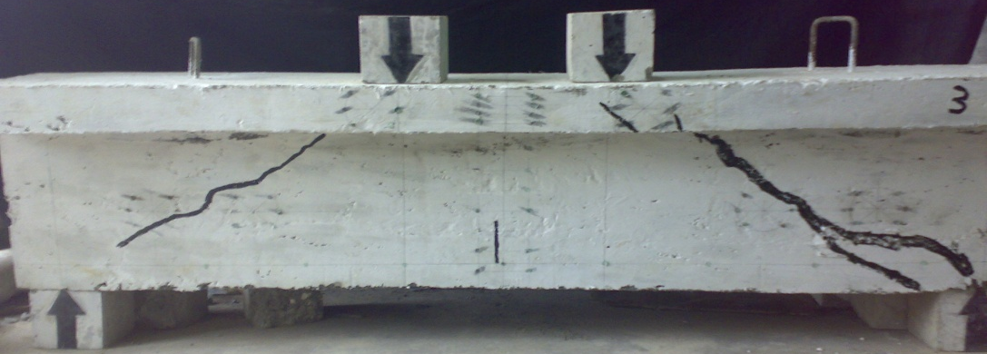
(a) beam L1M1m0
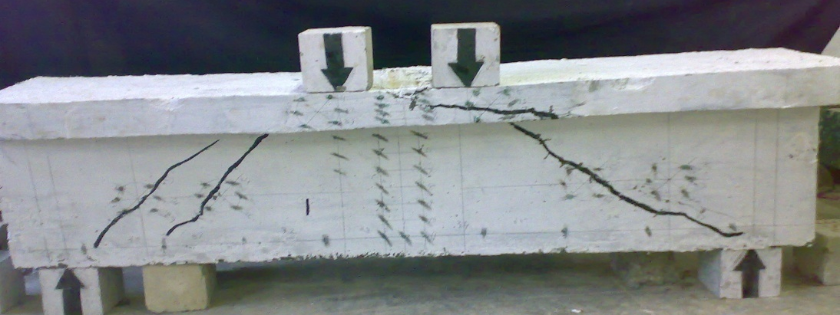
(b) beam L1M1m1
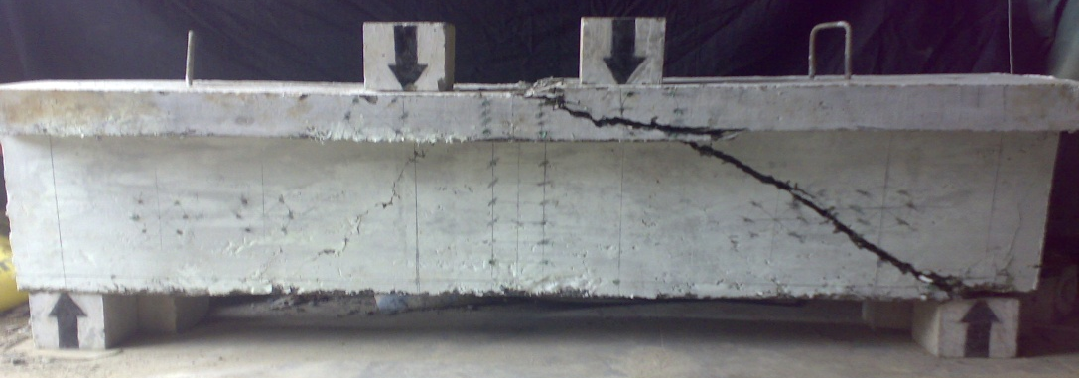
(c) beam L2M1m0
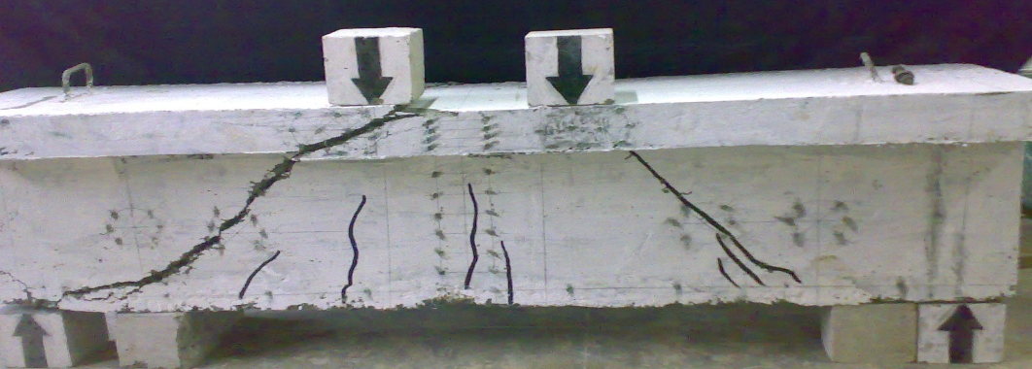
(d) beam L2M1m1
Fig 1 Cracks in fiber reinforced concrete beams

Table 2 Test results
Specimen  designation | Failure Load  (kN) | Shear strength  (kN) | Percentage increase in strength | Mid span  Deflection corresponding to peak load  (mm)
L1M0m0 | 761 | 380.5 | - | 7.5
L1M1m0 | 1033 | 516.5 | 36percent | 6.8
L1M1m1 | 1168 | 584.0 | 54percent | 6.5
L2M0m0 | 804 | 402.0 | - | 6.5
L2M1m0 | 1219 | 609.5 | 52percent | 6.2
L2M1m1 | 1234 | 617.0 | 54percent | 6.0

(a) set I beams | (b) set II beams
Fig 2. Mid span deflection response for beams

The load deflection response for the set I beams is given in Table 1. The deflection is considerably reduced for the test beam L1M1m1 containing Hybrid fibers of 1percent microfibers and 1percent microfibers, when compared with the corresponding mid span deflection of control beam L1M0m0 reinforced with no fibers and also with the corresponding mid span deflection of test beam L1M1m0 containing 1 percent microfibers and zero percent microfibers. Fig 2(b) shows load verses mid span deflection response for the set II beams. The deflection is reduced for the test beam L2M1m1 containing Hybrid fibers of 1percent microfibers and 1percent microfibers, when compared with the corresponding mid span deflection of control beam L2M0m0 reinforced with no fibers and also with the corresponding mid span deflection of test beam L1M1m0 containing 1 percent microfibers and zero percent microfibers.

CONCLUSIONS
Based on the present study following conclusions were made
• The increase in shear strength of the beam with the use of hybrid micro and macro fiber is greater than the increase in the shear strength of beam when only macro fibers are used
• The mid span deflection of the RC beam containing hybrid fibers is found to be lower than corresponding data of the beam containing macro fibers. This indicates that the hybrid fibers are effective in increasing the overall stiffness of the beam.
• More number of cracks are seen in hybrid steel fiber concrete beams when compared to the corresponding macro steel fiber concrete beam
The hybrid steel fibers shall be recommended to enhance the strength and stiffness of the RC beams.

References
- A Anbuvelan,., M.M Khadar,., M.Lakshmipathy., and K.S Sathyanarayanan,.,(2007), “Studies on properties of concretes containing polypropylene, steel and reengineered plastic shred fiber”, The Indian Concrete Journal,81(40), 38-44
- P Baruah,., and S.Talukdar, (2007), “A comparative study of compressive, flexural, tensile and shear strength of concrete with fibers of different origins”, The Indian Concrete Journal, 81(7), 17-24.
- N.Ganesan, , P.V.,Indira, and S. P.T Kumar. (2006), “Ultimate strength of steel fiber reinforced self compacting concrete flexural elements”, The Indian Concrete Journal, 80(12), 8-15
- T. Greenough, , and M.Nehdi, (2008), “Shear Behavior of Fiber-Reinforced self consolidating concrete slender beams”, ACI Material Journal, 105(5), 468-477.
- Y.K Kwak ,., M.O., Ebernard, W.S Kim,., and J.Kim, (2002), “Shear strength of steel fiber reinforced concrete beam without stirrups, ACI Structural Journal, 99(4), 530-538
- A.E. Naaman, and V.S. Gopalaratnam, (1983), “Impact properties of steel fiber reinforced concrete in bending”, The International Journal of cement composites and light weight concrete, 5(4), 225-233
- J.Thomas, , and .A Ramaswamy (2007), “Shear of prestressed concrete beams with steel fibers”, ICE, Journal of structures &Buildings, 160(5), 287-293

