American Journal of Engineering Research (AJER)
e-ISSN : 2320-0847 p-ISSN : 2320-0936
Volume-1 pp-49-53
www.ajer.org

Research Paper Open Access

Performance evaluation of coir geo-textiles as earth reinforcement in soil structures

Shaheem S and Tomy Cyriac
National Transportation Planning and Research Centre, Thiruvananthapuram

Abstract: - Coir geo-textiles offer a major solution for subgrade improvement and embankment protection. They have greater uniformity and strength and are capable of fabrication into products of controlled specifications. Coir geotextiles can be either non-woven or woven coir matting of various yarns with different mesh size is locally available and most suited to Kerala conditions. Based on the performance evaluation studies conducted on coir geotextiles laid reinforced roads and embankments, use of coir geotextiles in subgrade reinforcement and soil structure protection are found to be very effective in soft soils.

Keywords: - coir; geo-textiles ; soil; structures

INTRODUCTION
Coir geotextiles have become the most popular coir based innovation in recent times that is non-conventional eco-friendly and an economical means in earth reinforcement and embankment protection. The application of coir geotextiles as a solution against earth reinforcement and embankment protection is simple and easy. Coir geotextiles can be used as different layers in structural filling and embankment construction. The main advantage of geotextiles with natural fibres is that they are ecofriendly and biodegradable. Coir geotextiles have a great potential for application in improving the strength of weak sub-grade soils.

LITERATURE REVIEW
Mehndirata et al. [1] conducted a study based on the natural geo-textiles in highway embankments. In this study, they made an effort to increase the life of coir as well as to reduce the microbial attack and faster degradation by using chemical agents. Babu et al. [2] had formulated a new design methodology using IRC Guidelines, to reinforce the sub-grade using a natural geo-textile so as to improve the strength of sub-grade. In this paper, a design methodology using IRC Guidelines for the design of Coir geo-textile reinforced roads had been found out on the basis of laboratory experimental data and mathematical formulations when the CBR value is less than 2 percent. The method adopted was to reinforce the sub-grade using geo-textiles. Babu et al. [3] had conducted studies based on the load deformation behaviour of unpaved roads due to the placement of coir geotextiles on the basis of certain laboratory investigations. The four fundamental reinforcement mechanisms such as separation, lateral restraint, improved bearing capacity and tensioned membrane effect has been identified which reveals the use of geotextiles in unpaved road construction. The experiments were carried out by using commercially available three varieties of coir geotextiles (two woven type designated as H2M6, H2M8 and one non-woven type, AGLC/201) placed at sub-grade sub-base interface and also between layers of sub-base. Babu et al. [4] had reported the results of exhaustive study carried out to explore the behaviour of coir geotextile reinforced subgrade soils in terms of California Bearing Ratio. From the studies, it is clear that the presence of coir geotextiles influences the strength of subgrade due to the interaction between soil and coir geotextile in soaked and unsoaked condition. Balan [5] had successfully used coir geotextles in limited applications of geotechnical engineering. This paper deals with an overview of various case studies and model studies conducted by the author on the various uses of coir geotextiles. It gives an overview on the potential uses of geotextiles in various civil engineering applications.

NEED FOR THE STUDY
The necessity for usage of coir as geotextiles for earth reinforcement and soil structure protection arises from the fact that some sections of the road network happens to be routes over areas containing soft marine clays under water logged conditions. Low bearing capacity and improper drainage of the fine grained soils result in early failure of these roads. National Transportation Planning and Research Centre (NATPAC) seek the help of Local Self Government Department and Public Works Department to evaluate the performance of coir geotextiles in road subgrade improvements and soil structure protection. Some of the road stretches where, coir geotextiles laid for embankment protection and subgrade improvements were selected for performance evaluations studies.

OBJECTIVES OF THE STUDY
The major objectives of the study are:
• To ascertain the need for research in the field of use of Coir as geotextiles in road subgrade reinforcement and embankment protection.
• To explore the possibility of usage of coir as geotextile in road construction on a large scale basis in Kerala.
• To develop a methodology of using coir as geotextile for the protection of subgrade and soil structures in low lying areas with soft clay and under water logged conditions.
• To conduct field studies to evaluate the performance of roads using coir geotextiles.

Based on the scope and objectives of the study, the methodology of the study was derived and is shown as the flow chart in Fig 1.

PERFORMANCE EVALUATION STUDIES
Performance evaluation studies include functional and structural evaluation of the road pavement stretch.

Functional evaluation
• Roughness measurement using Bump Integrator (Functional Evaluation)-Roughness or Unevenness is a functional parameter, which affects the riding quality of pavements. This is measured using Bump Integrator, which directly gives the unevenness in cm on a panel board fitted with digital counters. The standard measure of the road roughness is the International Roughness Index (IRI).
• Condition Survey (cracks, raveling, potholes, rutting, edge break etc.)
• Skid resistance using portable skid resistance pendulum - Skid resistance is the resistance offered by the pavement surface against skidding of vehicles. Portable skid resistance tester is used for the study.
• Texture Depth Using Sand Patch Method - To measure the pavement macro texture. The geometrical disposition of the individual aggregates in the surface characterizes its macro texture. Coarser texture results in quick drainage of water and less pavement slipperiness.

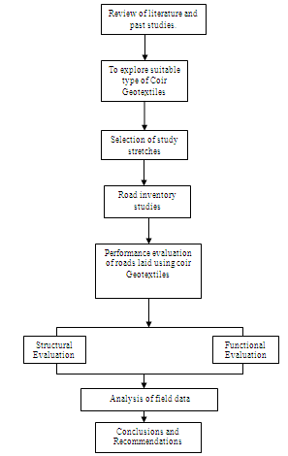
Fig. 1 Flow chart showing methodology adopted for the study
Structural evaluation
• Inventory (width, camber etc.)
• Deflection measurement using Benkelman Beam - Benkelman Beam Deflection technique is used for the structural evaluation of flexible pavements. The strength of a road pavement is inversely related to its maximum deflection under a known dynamic load. The equipment used for measuring the deflection is Benkelman Beam, which meets the requirement of IRC 81(1997).

PAVEMENT EVALUATION ON ROADS WITH COIR GEO-TEXTILES
As part of the project demonstration of the use of coir geotextiles in road construction, NATPAC initiated pavement evaluation studies on roads laid with coir geotextiles between subgrade and sub base layers and coir geotextiles laid for embankment protection. Two road stretches were selected in Thiruvananthapuram District for pavement evaluation studies, where coir geotextiles were laid between subgrade and subbase layers. This was done part of the joint research project undertaken by Coir board and College of Engineering, Trivandrum. Pavement evaluation surveys were carried out by NATPAC on two road stretches such as Attukal – Pambadi and Njekkadu – Panayara Road near Varkala in Thiruvananthapuram district. The following are the details of the road stretches selected for the study in Table 1.

Table 1 Stretches of road selected for study
Sl. No. | Name of road | Name of block | Length of test stretch
1 | Attukal – Pambadi road | Nedumangadu | 150m
2 | Karikkuri – Chekidampara road | Nedumangadu | 470m
3 | Njekkadu – Panayara Road | Varkala | 100m

NATPAC with the help of Public Works Department (PWD) also identified a road stretch, Kidangara – Kumarangiri near Alapuzha - Changancherry road, where coir geotextiles are laid to protect soil structure. This road stretch was frequently damaged because of erosion of road banks after every rain season and finds it very difficult to manage its routine maintenance activities. PWD Engineers and Vellandu Grama Panchayath Officials with the help of MGNREGS laid coir geotextiles along 1Km of the study stretch in January 2012 to protect road embankment stretch. NATPAC had decided to evaluate the performance of Kidangara - Kumarangiri road stretch where coir geotextiles were laid for embankment protection.

Coir Geotextile Reinforced roads
Attukal - Pambadi road : Attukal-Pambadi road is a rural road stretch near Nedumangadu in Thiruvananthapuaram district. The road stretch carries very low volume of traffic with a carriageway width of 3.5 m. Coir geotextiles of H2M5 grade were laid about 150m length by Local Self Government Department under the technical supervision of College of Engineering Trivandrum in November 2010. Fig 2 below shows the cross sections adopted for Attukal - Pambadi road laid under PMGSY scheme. Fig 3 shows the pavement evaluation done in Attukal - Pambadi road.
NATPAC initiated evaluation of performance of coir geotextiles reinforced road in Attukal – Pambadi road. An exhaustive condition survey and BBD survey was done to evaluate the functional and structural performance of the road. A control section of 100m length was taken along the road stretch to compare the performance of roads laid without coir geotextiles. The summary of the results of the survey is given in Table 2.
An exhaustive condition survey and BBD survey was done to evaluate the functional and structural performance of the road. A control section of 100m length was also taken along the road stretch to compare the performance of roads laid without coir geotextiles. The summary of the results of the survey is given in Table 2.

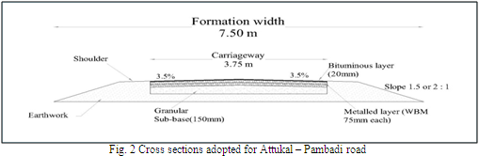
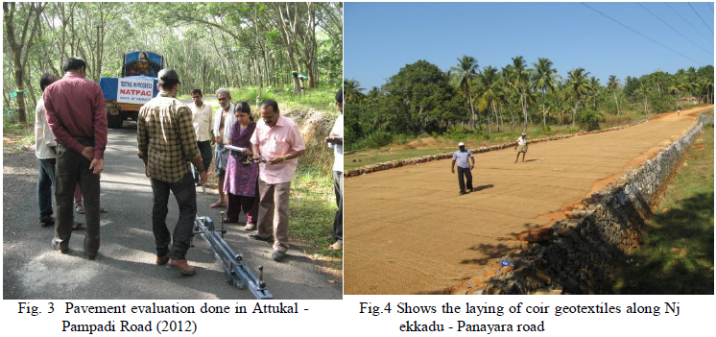

Table 2 Summary of BBD results
Road Name | Characteristic Deflection (mm)
 | Type | Stretch with coir | Control stretch
Attukal - Pambadi road | Coir 1 (H2M5) | 0.72 | 1.03
Njekkadu - Panayara Road | Coir 2 (H2M6) | 0.81 | 0.81

Coir Geotextiles for soil structure protection
Kidangara - Kumarangiri road: Kindangara- Kumarangiri road is located near to the Alapuzha - Changanachery State Highway. Both sides of the road are paddy fields. Roads are deteriorating fast every after the monsoon due to the erosion of road banks and under water logged condition. Therefore authorities of Vellanad Grama Panchayath with the help of Coir Board, laid Coir geotextiles about 1km ( Gurupuram - MLA Bridge) along the road embankment. This coir protected embankment stretch was selected for performance evaluation along with another 1km control stretch of un protected embankment stretch. Fig 5 shows the laying of coir geotextiles, coir geotextiles laid study stretch and BBD survey in progress along Kidangara- Kuaramgiri road.
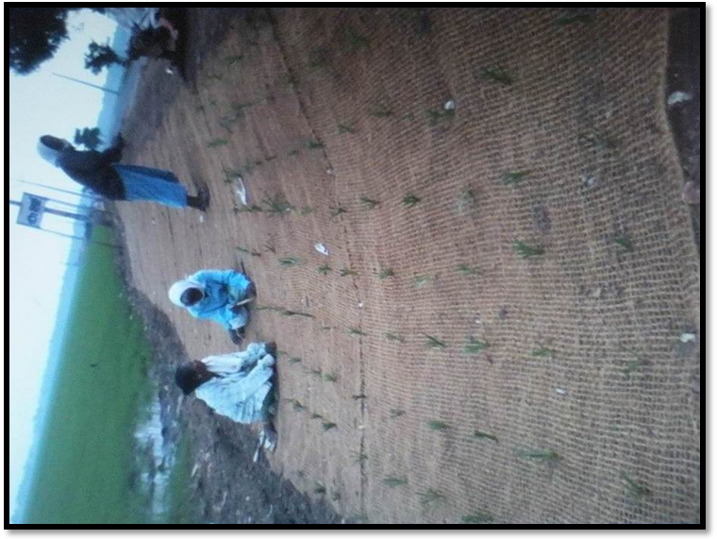
NATPAC initiated evaluation of performance of coir geotextiles laid road in Kindanagra - Kumarangiri road about 1km length. Traffic volume plying through the road is very low (ADT 800 PCU) and also it attracts reasonable amount of truck traffic during the harvest season. An exhaustive condition survey and BBD survey was done to evaluate the functional and structural performance of the road. A control section of 1Km was also taken along the road stretch to compare the performance of roads laid without coir geotextiles. Summary of BBD and IRI values are given in Table 3 and 4.

Fig. 5 Shows laying of coir mats in progress on road embankment from Gurupuram to MLA Bridge under MGNREGS
Table 3 Summary of BBD results
Road Name | Characteristic Deflection (mm)
 | Type | Stretch with coir | Control stretch
Kidangara – Kumarangiri (Changanassery) | Coir  (H2M5) | 0.75 | 1.01

Table 4 Unevenness values on Study Road
Road Name | IRI mm/km
 | Type | Stretch with coir | Control stretch
Kidangara – Kumarangiri (Changanassery) | Coir  (H2M6) | 6339 | 10060

CONCLUSIONS AND RECOMMENDATIONS
Coir Geotextiles offer a major solution for subgrade improvement and soil structure protection. Based on the performance evaluation studies conducted on coir geotextiles laid reinforced roads, it is found that H2M5 grade (700g/m2) laid reinforced roads perform better than H2M6 grade (400g/m2) coir geotextiles. The study conducted using coir geotextiles for embankment protection shows that the coir geotextile laid embankments perform very good in terms of functional and structural evaluation. The coir geotextiles with grass appeared to be very effective in preventing erosion, to retain moisture and to facilitate stability of road pavements. Road Condition survey done along the road stretches with and without coir geotextiles along embankment shows that road pavement deteriorates severely in control stretch without coir geotextiles. Summary of Benkle Beam Deflection test results shows that characteristic deflection is high (1.01) in control stretch compared to the coir geotextile laid embankment stretch (0.75).
Unevenness values of the study road stretch shows that IRI value is very low in control stretch where coir geotextiles were not laid, compared to the study stretch, where coir geotextiles were laid for the protection of road embankments. Therefore it can be concluded that the use of coir geotextiles in subgrade reinforcement and road side embankment protection are very effective. It is also recommended to construct more test tracks using different grade coir geotextiles under different soil conditions to further evaluate their performances.

ACKNOWLEDGMENTS
The Authors are thankful to Smt. B.G Sreedevi, Director, National Transportation Planning and research Centre, Thiruvananthapuram for her guidance and to Salini P.N, Scientist-B and Wilson. K.C, Scientist-B for their inputs and assistance in carrying out this study

REFERENCES
- H.C. Mehndirata,. P. Kumar, T. Padma (2005), “Natural Geo-Textile In Highway Embankments- Indian Experience”, Indian Highways, August, 57.
- K.K. Babu, K.S.Beena And A.K. Raji (2008a) “Design Of Coir Geo-Textile Reinforced Roads Using IRC Methods”, Highway Research Journal, Special Issue , 113.
- K.K. Babu, K.S.Beena and A.K. Raji, (2008b), “Load Deformation Behaviour of Coir Geotextile Reinforced Unpaved Roads” Indian Highways, July, 33-39.
- K.K. Babu, K.S.Beena and A.K. Raji, (2011), “Estimation of CBR of coir geotextile Reinforced subgrade”, Indian Highway Research Journal, July – December, 41-47.
- K. Balan. (2012),”An overview of case studies and model studies with coir geotextiles”, Geosynthetics Asia 2012, 5th Asian regional Conference on Geosynthetics, Bangkok, Thailand, December, 1-8.

