American Journal of Engineering Research (AJER)
e-ISSN : 2320-0847 p-ISSN : 2320-0936
Volume-4 pp-22-28
www.ajer.org

Research Paper Open Access

Parametric study on the transverse and longitudinal moments of trough type folded plate roofs using ANSYS

Tibu Chacko¹, Ramadass S² and Jayasree Ramanujan¹
¹Civil Engineering Department, Mar Athanasius College of Engineering, Kothamangalam, Kerala, India
²Division of Civil Engineering, Cochin University of Science and Technology, Kochi-682 022, Kerala, India

Abstract: - This paper deals with the influence of various parameters on the transverse moments developed at the joints & the longitudinal moments developed at mid span section of individual plates and the mid span deflection response of trough type folded plate roofs. The parameters considered in this study are angle of inclined plate, width to depth ratio of a single trough and the span to inclined plate width ratio of a single trough. The magnitude of angle of inclined plate considered is 30º to 70º.The width to depth ratio is varied from 2.5 to 10.0. The span to inclined plate width ratio is varied between 5 and 22.The transverse & longitudinal moments developed and the mid span deflection response of trough type folded plate roof are predicted using the model proposed by ANSYS 12.0 software. The results of the study give an insight to the range for the magnitude of the various parameters to be considered for the optimum performance of trough type folded roofs.

Keywords: - ANSYS , Folded Plates, Longitudinal moment, Mid span deflection, Transverse moment

INTRODUCTION
A folded plate structure may be considered as a series of girders leaning against each other. With folded plate structure, efficiency of material usage is increased since the slopping plates of the deep structural beams not only carry primary web shear but also serve as a structural deck and often used as finished interior ceilings. Folded plates are a very useful form of structure for roofing large column-free area. Among the different types, trough type folded plates are commonly used for roofing larger spans. The analysis and design of trough type folded plate roof consists in assuming a preliminary section and checking the stresses. Since the analysis is a difficult task without a computer, the designer will have a tendency to assume an over safe preliminary section and satisfy himself that the design is safe [1]. Computer programs are developed for classical methods of analysis but they did not show much correlation with manual calculation results [2]. In tandem, with the advances in computing and computational approaches, numerical methods of analyzing complex structures have attracted increasing attention. The numerical methods include finite strip method, the combined boundary element - transfer matrix method and finite element method. Of these methods finite element method is the most versatile method, as it can be applied to analyze large complex structures [3]. Limited studies have been reported on the influence of the angle of inclined plate, width of inclined plate and depth of folded plate roofs on the transverse moments, deflection and longitudinal moments of folded plate roofs. Folded plates can be analyzed by classical methods, namely, Simpson’s method, Whitney’s method and iteration methods. The folded plates can also be analyzed by numerical methods. The classical method proposed by Simpson (1958) has been considered for the manual analysis. The numerical method proposed by ANSYS software has been considered for the computer analysis. In this paper, a typical trough type folded plate of standard dimension adopted in practice has been considered. The final transverse moments at each of the joints are predicted using the model proposed by Simpson’s method (1958) and by the numerical method using ANSYS software. The results obtained from the classical method are compared with the corresponding results obtained from the numerical method. The comparison is done to check the validity of the application of ANSYS software for the present parametric study. In this paper, the influence of various parameters, namely, angle of inclined plate, width to depth ratio of a single trough and the span to inclined plate width ratio of a single trough on the transverse moment developed at the joints & the longitudinal moment developed at mid span section and the mid span deflection response of trough type folded plate roofs have been reported. The parametric study is carried out using ANSYS software.

ANALYTICAL MODEL
2.1 Simpson’s method
Simpson’s method is involved in determining the transverse moments and longitudinal stresses at the joints. The analysis of folded plates is reduced to a series of moment and stress distributions, involving only simple arithmetic. In this method the basic structure is assumed as a folded plate with rigid joints. To start with, the rigid joints are assumed to be non-deflecting. The effects of rigid displacements are subsequently accounted for. This is done by allowing each plate in turn to rotate at mid-span by an arbitrary amount. Each of the rotation solutions are multiplied by a constant and are added to the no-rotation solution to give the final solution. The equations involved in the analysis of folded plate roof using Simpson’s method are listed as follows.

Fixed end moment at joints considering arbitrary rotation of plate 2 = $\left(\frac{3EI_{n}}{h_{n}} \right)X( \frac{∆_{n0}}{h_{n}} )$ (1)
Fixed end moment at joints considering arbitrary rotation of plate 3 & 4 = $\left(\frac{6EI_{n}}{h_{n}} \right)X( \frac{∆_{n0}}{h_{n}} )$ (2)
Plate moment corresponding to no rotation solution = $\frac{{(f}_{b}-f_{t}) h_{n}d_{n}}{2} (\frac{h_{n}}{6})$ (3)
Plate deflection at mid span corresponding to no rotation, υ_{n} = $\frac{{5l^{2}(f}_{b}-f_{t})}{48Eh_{n}}$ (4)
Plate deflection corresponding to rotation of plates, υ_{n} = $\frac{{l^{2}(f}_{b}-f_{t})}{π^{2}Eh_{n}}$ (5)
Plate rotation equations
Ψ_{n} = $\left( \frac{1}{h_{n}} \right)[(υ_{n}\left(cotϓ_{n}+ cotϓ_{n-1}\right)-\left(\frac{v_{n+1}}{\sin{ϓ_{n}}}\right)-$ $\left(\frac{v_{n-1}}{\sin{ϓ_{n-1}}}\right)$] (6)
Ψ_{n+1} = $\left( \frac{1}{h_{n+1}} \right)[(υ_{n+1}\left(cotϓ_{n+1}+ cotϓ_{n}\right)-\left(\frac{v_{n+2}}{\sin{ϓ_{n+1}}}\right)-$ $\left(\frac{v_{n}}{\sin{ϓ_{n}}}\right)$] (7)

where E is the young’s modulus, I is the moment of inertia of the section considered, ∆_{no} is the arbitrary deflection, h_{n} is the width of plate, f_{t} and f_{b} be the fiber stresses at top and bottom of the plate, l is the span length, υ_{n} is the plate deflection, Ψ_{n} is the plate rotation, ϓ_{n} is the angle between plates n and n+1.

  - ANSYS software model
ANSYS provides solutions to many types of analyses problems including structural, thermal, linear buckling and shape optimization studies. ANSYS is an intuitive mechanical analysis tool that allows geometry to be imported from a number of different CAD systems. It can be used to verify product performance and integrity from the concept phase through the various product design and development phases. Detail of the shell element used is given. In this paper, ANSYS12.0 is used for the analysis.

2.2.1 Element details, shell 63
Shell 63 has been used as the element in the computer analysis. It has both bending and membrane capabilities. Both in-plane and normal loads are permitted. The element has six degrees of freedom at each node: translations in the nodal x, y, and z directions and rotations about the nodal x, y, and z-axes. Stress stiffening and large deflection capabilities are included. The geometry, node locations and the coordinate system for Shell 63 are given in Fig.1. The element is defined by four nodes, four thicknesses, elastic foundation stiffness, and the orthotropic material properties. Orthotropic material directions correspond to the element coordinate directions. The element coordinate system orientation is as described in coordinate systems. The element x-axis may be rotated by an angle THETA (in degrees).The thickness is assumed to vary smoothly over the area of the element, with the thickness input at the four nodes. If the element has a constant thickness, only TK(I) need be input. If the thickness is not constant, all four thicknesses must be input.

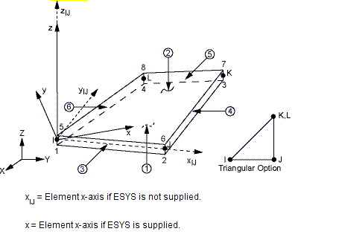
Fig.1 Shell 63

DETAILS OF FOLDED PLATE FOR THE ANALYSIS
A trough type folded plate roof of standard dimension adopted in practice has been considered and is given in Fig.2. All dimensions given in Fig. 2 are in meters. The span of the folded plate is assumed as 18.3m. The depth of the folded plate roof is 0.95 m. The live load on the roof is assumed as 0.7 kN/m2. The grade of concrete assumed is M25. The final transverse moments at each of the joints are predicted using the models proposed by Simpson’s method (1958) and by the numerical method using ANSYS software. The results obtained from the classical method are compared with the corresponding results obtained from the numerical method. The comparison of results is given in Table 1. The comparison indicates that the prediction by the numerical model is in good agreement with the prediction proposed by Simpson’s method. This indicates that the application of shell element 63 in ANSYS software is valid for further parametric studies.

Table.1. Transverse moments at joints using Simpson’s method and numerical method
Joint | Transverse moments in N-m |  | Ratio of predicted moments  Ms/Mn
 | Simpson’s method  Ms | Numerical method  Mn
0 | 0 | 4.11e-9 | 0
1 | -91.9 | - 87.226 | 0.95
2 | 4545 | 4282.2 | 0.94
3 | -3920.7 | - 4070.1 | 1.03
4 | -1664.6 | - 1375.5 | 0.83

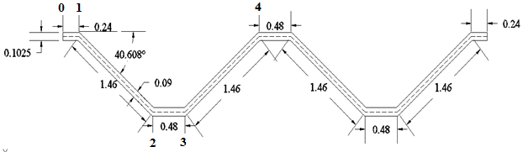
Fig.2. Details of folded plate roof

PARAMETRIC STUDY
The parametric study is carried out by assuming the typical trough type folded plate roof given in Fig.3. In Fig 3, L is the span of the folded plate, W is the width of single trough unit and B is the width of the inclined plate and θ is the angle of inclination of plate with the horizontal. The influence of various parameters, namely, angle of inclined plate, width to depth ratio of a single trough and the span to inclined plate width ratio of a single trough on the transverse moment developed at the joints & the longitudinal moment developed at mid span section and the mid span deflection response of trough type folded plate roofs are analyzed. The parametric study is carried out using ANSYS software.
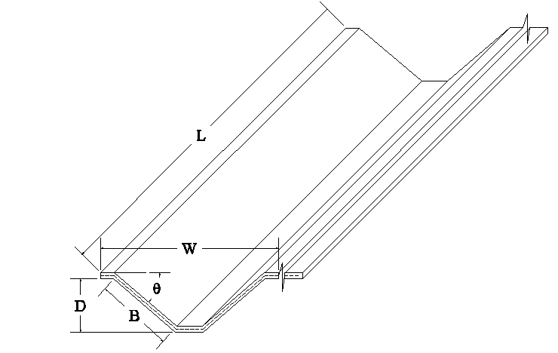
Fig 3.Typical folded plate roof

4.1. Influence of angle of inclined plate on the mid span deflection response of the folded plate roof when the length to width (L/B) ratio is constant
The influence of angle of inclined plate on the mid span deflection response of the folded plate roof is analyzed and is given in Fig.4. The span length (L) of the folded plate roof is taken as 18.3m.The width (B) of the inclined plate is taken as 1.46m. Hence the length to width (L/B) ratio of inclined plate of the folded plate roof is kept constant and is equal to 12.5.The angle of inclination of the inclined plate is varied from 30º to 70º. The variation in the mid span deflection of the folded plate roof is observed. From Fig. 4, it is found that as the angle of inclined plate increases the mid span deflection of the folded plate roof decreases.

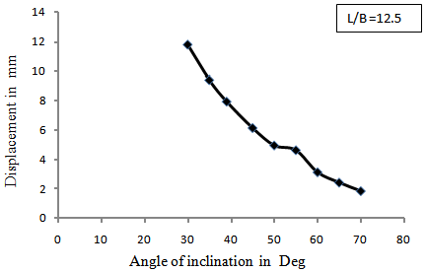
Fig. 4 Influence of angle of inclined plate on the mid span deflection of the folded plate roof

4.2 Influence of angle of inclined plate on the transverse moments Mz at the joints when the length to width (L/B) ratio is constant
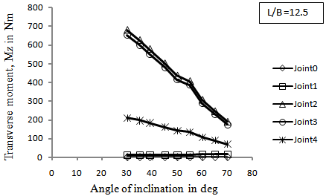
Fig. 5 Influence of angle of inclined plate on the transverse moments Mz
The influence of angle of inclined plate on the transverse moment Mz at each of the joints of the folded plate roof is analyzed and is given in Fig.5. The length to width L/B ratio of inclined plate of the folded plate roof is kept constant and is equal to 12.5 and the angle of inclination of the inclined plate is varied from 30º to 70º. The variation in the transverse moment Mz at each of the folded plate roof is observed. From Fig 5 it is found that as the angle of inclined plate increases the transverse moment at joints decreases. The transverse moment at joint 0 is found to be constant and is equal to zero, as the joint 0 is a free joint. The transverse moment at joint 1 is also found to be constant and is found to be greater than the transverse moment at joint 0 for the corresponding angle of plate. A gradual decrease in the transverse moment at joint 4 can be observed when the angle of plate increases. In the joints 2 and 3, a steeper decrease in the transverse moment can be observed when the angle of plate increases. The transverse moments at joint 2 is found to be greater than the transverse moment at joint 3 for the corresponding angle of plate.

4.3 Influence of angle of inclined plate on the longitudinal moment Mx when the width to depth (W/D) ratio is constant
In this study, the width to depth ratio of a single trough unit is made constant and the angle of inclination of the intermediate plate is varied. The length of the folded plate (L) is made constant and is equal to 18.3 m. The width of the folded plate trough (W) is made constant and is equal to 3.2 m and the depth of the trough is made constant and is equal to 0.73 m. Hence the width to depth (W/D) ratio of the folded plate trough is a constant value and is equal to 4.4.The angle of inclination of the inclined plate is varied from 30º to 50º. The variation in the longitudinal moment Mx at mid span section at each of the joints of folded plate roof is given in Fig 6. From Fig 6, it is found that as the angle of inclined plate increases the longitudinal moment at mid span at each of the joints decreases. Joint 3 carry the highest moment when the angle of plate increases. When the angle of plate is 45 degrees, the longitudinal moment at joints 1 and 2 are found to be equal. When the angle of plate is more than 45 degrees, the longitudinal moment at joint 1 is found to be greater than the longitudinal moment at joint 2. When the angle of plate is less than 45 degrees, the longitudinal moments at joints 1, 2, 3 are found to be more than the longitudinal moments at joints 0 and 4.When the angle of plate is more than 35 degrees, joint 3 carries the lowest longitudinal moments. When the angle of plate is less than 35 degrees, the longitudinal moment at joint 0 is found to be greater than the longitudinal moment at joint 4.When the angle of plate is 35 degrees, the longitudinal moment at joint 0 and joint 4 are found to be equal in magnitude.

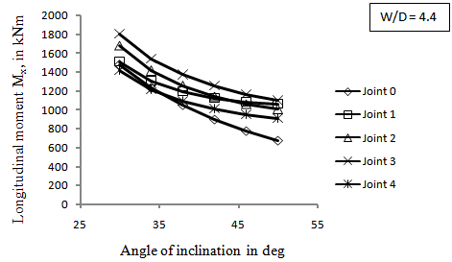
Fig. 6 Influence of angle of inclined plate on the longitudinal moments Mx

4.4 Influence of width to depth (W/D) ratio on the longitudinal moment Mx
The angle of inclination of intermediate plate is made constant and is equal to 40º to the horizontal, The length of the trough (L) is made constant and is equal to 20m, The width of the single trough(W) is made constant and is equal to 2m.The depth of the trough (D) is varied from 0.2 to 0.8 m. The influence of width to depth (W/D) ratio ranging from 2.5 to 10.0 on the longitudinal moment Mx is given in Fig.7. For all values of W/D ratios ranging from 4.5 to 10.0, the longitudinal moments at joints 0, 1 and 3 are found to be higher than the longitudinal moments at joints 2 and 4.The longitudinal moments are found to be higher and equal in magnitude at joints 0, 1 and 3 for each of the W/D ratios ranging from 5.0 to 10.0. The longitudinal moments are found to be lower and equal in magnitude at joints 2 and 4 for each of the W/D ratios ranging from 5.0 to 10.0. When W/D is equal to 4.54, the longitudinal moments remain constant at all the joints. When W/D ratios are 4.0 and 3.3, the longitudinal moments decreases gradually at joints 0, 1, 2 and 3 and increases gradually at joint4. When W/D=2.5, the longitudinal moment is found to be constant at joints 0 and 1 and increases gradually at joint 2 and decreases at joint 3 and increases at joint 4.

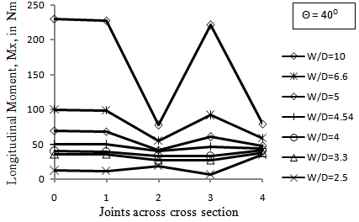
Fig 7 Influence of width to depth (W/D) ratio on the longitudinal moment Mx

4.5 Influence of span to inclined plate width (L/B) ratio on the longitudinal moment Mx
The length of the folded plate (L) is made constant and is equal to 20m. The width to depth ratio(W/D) of single trough unit is made constant and is equal to 4.54 .The span to inclined plate width (L/B) ratio is varied from 5 to 22 and the longitudinal moment on the inclined plate is computed. The influence of span to inclined plate width (L/B) on the longitudinal moment Mx developed in the inclined plate is given in Fig.8. When the value of L/B increases from 5 to 8, the longitudinal moment on the inclined plate increases and reaches a maximum value at L/B equal to 8. When the value of L/B increases from 8 to 18, the longitudinal moment on the inclined plate decreases and reaches a minimum value at L/B equal to 18. When the value of L/B increases from 18 to 22, the longitudinal moment on the inclined plate increases. From the Fig 8, it is understood that the longitudinal moment is found to be maximum when L/B is 8 and is found to be minimum when L/B is 18. It is also observed that the longitudinal moment on the inclined plate is found to be almost equal in magnitude when L/B ratios are 5 and 8.
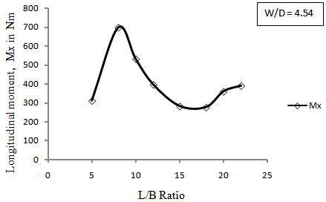
Fig.8 Influence of span to inclined plate width (L/B) on the longitudinal moment Mx

CONCLUTIONS
Based on the parametric study, following conclusions are arrived at.
• The angle of inclined plate greatly influences the transverse moments at the joints, longitudinal moments at the mid span section and the mid span deflection response of folded plate roofs.
• It is found that as the angle of inclined plate increases, the mid span deflection response, the transverse moment at the joints and the longitudinal moment at mid span section at each of the joints decreases.
• Based on the Indian standard code for the criteria for design of reinforced concrete shell structures and folded Plates IS:2210(1988), the angle of inclination of the plate to horizontal is limited to 40º for in-situ construction in order to facilitate the placing of concrete without the use of the back forms[4]. From the parametric study, it is found that as the angle of plate increases the moment decreases. Hence the angle 40º is taken as the optimum angle for the design of folded plates.
• When width to depth ratio is 10, the magnitude of longitudinal moments at joints 1 and 3 is found to be maximum.
• When the span to inclined plate width ratio is 8, the longitudinal moment is found to be maximum.
• The longitudinal moment is found to be minimum and optimum when the span to inclined plate width ratio is 18.
• When width to depth ratio is equal to 4.54, the longitudinal moment is found to be reduced and remains constant at all the joints.

The parametric study made in this paper is useful for the design engineers to arrive at economical sections of trough type folded plate roof structures.

REFERENCES
[1] Lakshmy, T.K., Optimum design of trough type folded plate roofs, Computers and structures 57 (1) 1995, 125-130.
[2] Bandyopadhyay J.N. (1989), Comparative analysis of folded plate structures, Computers and structures, 36 (2), 1989, 291-296.
[3] Peng L.X,, Bending analysis of folded plates by the FSDT meshless method, Thin walled structures 44, 2006, 1138-1160.
[4] IS 2210(1988) Criteria for Design of Reinforced Concrete Shell Structures and Folded Plates Bureau of Indian Standards, New Delhi.
[5] Ramaswamy G.S. Design and Construction of Concrete Shell Roofs (McGraw-Hill Publishing Company, New Delhi, 1986)
[6] K. Chandrashekhara Analysis of thin concrete shell roofs ( New age publications,1995)
[7] ANSYS, Inc. engineering simulation software, Pennsylvania, United States.

