American Journal of Engineering Research (AJER)
e-ISSN : 2320-0847 p-ISSN : 2320-0936
Volume-4 pp-17-21
www.ajer.org

Research Paper Open Access

Seismic analysis of Wind Turbines using Opensees

Indu V S¹, Binu P¹ and Unnikartha G²
¹Department of Civil Engineering, Sree Narayana Gurukulam College of Engineering, Kadayiruppu, India.
²Department of Civil Engineering, Federal Institute of Science and Technology, Angamaly, India

Abstract: - In India, use of renewable energy is slowly catching up and quite a large number of wind turbines are being installed in various parts of the country. The seismic analysis of wind turbines is now gaining importance as more wind turbines are now installed in seismic prone regions and not many studies have been carried out in this field. This study is aimed to obtain the various bending modes and the seismic response of the wind turbine. Three Finite Element Models of the wind turbine was developed in Opensees Navigator which is an open source software for earthquake simulations. A stick model, a turbine tower with lumped mass and a model of the Turbine tower with blades. Stick model was the simplest model. The turbine tower modeled with nacelle and rotor blades are the full system models. The mode shapes and the seismic response of these three finite element models were determined and thereby the effects of these various finite element models on the seismic response were also studied. The data of the shake table experiment of the 65 kW turbines conducted at UCSD in November 2004 provide the basis for the finite element model development. This paper gives an overview on the seismic analysis of wind turbines using various finite element models in Opensees Navigator.

Keywords: - Turbine, Seismic response, Bending modes, Dynamic analysis, Opensees navigator.

INTRODUCTION
The wind industry continues to grow rapidly throughout India. Over one quarter of the turbines installed, are all in regions of high seismic hazard. Under-predicting this hazard exposes the operators and the communities dependent on wind power to undue risk. The growth of wind turbine installations has lead to an increased interest in the seismic analysis of wind turbines. Current practices for seismic analysis generally fall under finite element analysis.
Existing literature regarding modeling wind turbines for seismic analysis is divided between two types of models; models that focus on the tower by accounting for the mass of the nacelle and rotor as a point mass at the top of the tower; and models that describe the full turbine including the nacelle and rotor with detail. Simplified models are attractive as they remove the complexity of modeling the rotor [1]. The simplified approach may be unreliable for modeling behavior that arises from modes other than the first tower mode. In contrast, the full system models include the rotor and nacelle. Even though they are complex in interpreting results, they offer more flexibility. The results will be more reliable and accurate. Early investigations (Bazeos, 2002)[2] focused on the tower, using models that lumped the nacelle and rotor as a point mass .Bazeos et al[2] also provided a thorough comparison of dynamic response, employing a full shell-element, a simpler beam-column, and a single-degree-of-freedom model approach. More recent work (Witcher et al.2005) [3] used models that explicitly simulate the rotor along with the turbine tower.

II. AIM OF THE STUDY
The aim of this study is to obtain the bending modes and the seismic response of the turbine using three different finite element models ,using the software Opensees Navigator 2.5.1 .Hence the effect of various finite element models on the seismic response is investigated. The bending modes and the seismic response obtained for various finite element models are compared with that of the experimental results.

III. WIND TURBINE DESCRIPTION
A 65 kW turbine was adopted for the finite element analysis. The components of the turbine include a tower structure which supports the other units nacelle and rotor. The dimensions of the tower are illustrated in Fig 1(a) and its properties are described in Fig 1(b). The tower consists of three discrete hollow cylindrical sections. The outside diameter of each successive piece of the tower is reduced in relation to the bending response, to use material efficiently. The transition in diameter is accommodated by 1.9 m long tapered segments in the lower two sections (Prowella et al.2009) [4][5].

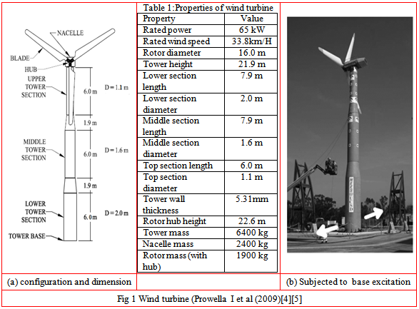

Excitation used for the tests was derived from a recording of the Desert Hot Springs (DHS) East-West component of the June 28th, 1992 Landers Earthquake (Prowella I et al (2009)[4][5] .DHS is a California Strong Motion Instrumentation Program (CSMIP) station situated on deep alluvium located 23 km from the fault trace where the Landers Earthquake occurred. The fig 1(c) shows the turbine subjected to base excitations in the east-west direction.

IV. FINITE ELEMENT ANALYSIS
4.1 Finite Element Modeling
Finite element models are useful for predicting the behavior of complex structures or structures with unusual loading, for which analytical methods are difficult to employ, and can be used to assess the seismic capabilities of such structures. Finite element models can be validated using a variety of methods (Tenguria et al. 2003) [6],.
Finite element modeling was carried out in Opensees Navigator. Three finite element models were developed. A stick model with lumped mass was initially developed by adopting beam-column elements in Opensees Navigator. Fig (3) shows the stick model of the turbine with lumped mass of the rotor and nacelle at its top. Next a turbine tower was modeled with lumped mass at its top. Tower was modeled using shell elements in open sees navigator .Fig (4) shows the turbine tower with lumped mass. A third model was developed by taking into account both the nacelle and rotor blades. Shell elements were adopted to model the tower as well as turbine blades. Fig (5) shows the model of the turbine tower with blades.

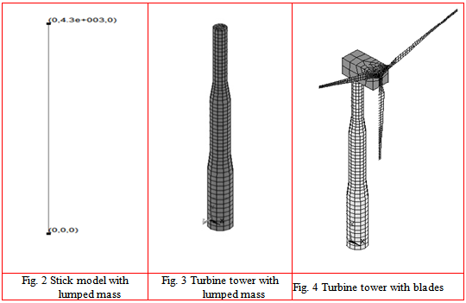

4.2 PEER Ground motion records
Details of the seismic excitation records of 1992 Landers Earthquake was downloaded from the Pacific Earthquake Engineering Centre and was applied to the Finite Element Model.
4.3 Finite element analysis
Initially Dynamic analysis was carried out so as to capture the dynamic behavior of the turbine. The mode shapes obtained clearly depicts the vibration characteristics of the turbine. Then transient analysis was carried out. Transient analysis is also known as ‘Time History Analysis. It was carried out for obtaining the seismic response, i.e., time dependant displacement, time dependant acceleration etc. Transient analysis was carried out for a period of 45 seconds.

V RESULTS
5.1 Mode Shapes
Mode shape is a graphical representation of the vibration characteristics of turbine. Each mode shape of the turbine corresponds to each frequency. The lowest frequency of vibration is called fundamental frequency and the corresponding displacement shape of vibration is called fundamental mode or first mode or first mode of vibration. The displacement shape corresponding to second higher natural frequency is called second mode of vibration. The displacement shape corresponding to third higher natural frequency is called third mode shape of vibration. The mode shapes obtained for various finite element models are as follows. Fig 6 shows the first three mode shapes of the stick model with lumped mass. Fig 7 shows the first three mode shapes of the turbine with lumped mass. Fig 8 shows the first three mode shapes of turbine tower with nacelle and rotor blades.

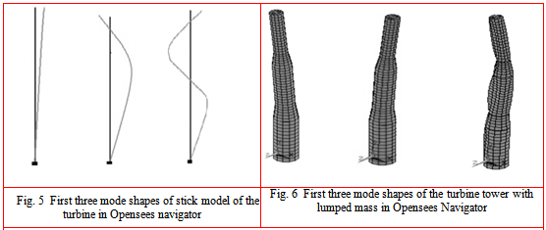
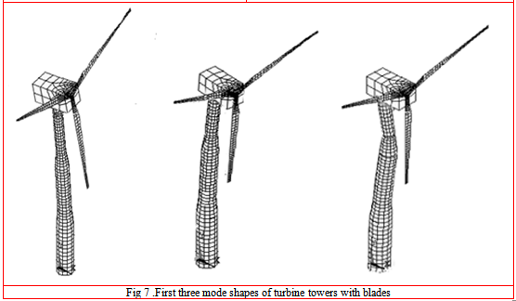

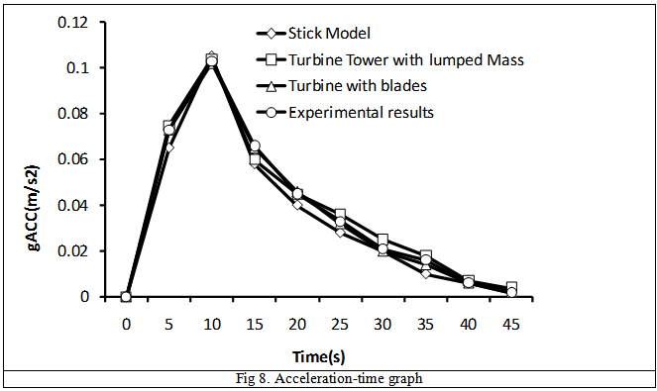

5.2 Seismic response
Fig 9 and Fig 10 depicts the seismic response of the turbine. The dynamic load applied to the system not only produces certain motions, but also cause certain associated stresses. The term seismic response indicates the time varying displacements and time varying accelerations obtained after seismic analysis. More commonly the seismic response indicates the displacement time history.

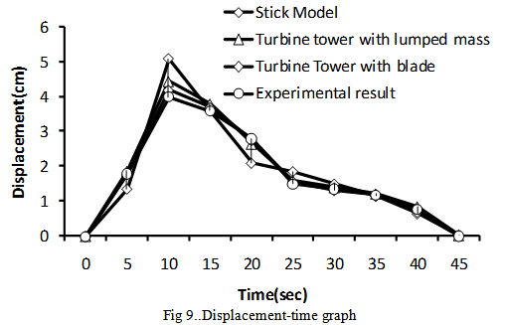
Table 2 Comparison of maximum displacement during 10 seconds
FE Model | Opensees Navigator | Experimental Results  (Prowella I et al (2009 )[4][5]
Stick Model | 5.2 cm | 4 cm
Turbine Tower with lumped mass | 4.5 cm | 4 cm
Turbine tower with blades | 4.2 cm | 4 cm

Table 3 Comparison of mode shapes
FE Model |  | Opensees Navigator | Experimental Results  (Prowella I et al (2009)[4][5]
Stick Model | 1st Mode | 1.589 Hz | 1.72 Hz
 | 2nd Mode | 10.585 Hz | 11-12 Hz
 | 3rd Mode | 31.829 Hz | 34.1 Hz
Tower with  Lumped Mass | 1st Mode | 1.702 Hz | 1.72 Hz
 | 2nd Mode | 11.015 Hz | 11-12 Hz
 | 3rd Mode | 33.965Hz | 34.1 Hz
Turbine with blades | 1st Mode | 1.726 Hz | 1.72 Hz
 | 2nd Mode | 11.802 Hz | 11-12 Hz
 | 3rd Mode | 34.241 Hz | 34.1 Hz

VI DISCUSSION OF RESULTS
The comparison of the mode shapes shows that the turbine towers modeled with shell elements are showing closer results with that of the experimental results than the stick model which are modelled using Beam-column elements. This shows that the usage of various types of finite elements in modelling really affect the results. Even though the simpler models are easier to develop, attractive and are easier in interpreting results, but they may be unreliable. The complex models may be difficult to develop and it may be difficult to interpret the results, but the results obtained are reliable. Since the shell elements have the capability to represent the thin canonical shell form of a real life tower, the turbine towers modelled with shell elements give closer results. Similarly the turbine tower modeled with turbine blades has their mode shapes very closer to the experimental results. This shows that the ‘full system models’, including the some level detail of nacelle and rotor gives closer results than the simpler models. While assessing the seismic response, it was found that the turbine towers with blades are showing closer results. The maximum displacement for the stick model showed clear deviation from the experimental results. This proves that simpler models are unreliable. Opensees Navigator is the GUI version of the Open source software, Opensees, developed by Pacific Earthquake Research Centre. It is software particularly used for Earthquake simulations. Even though it is open source software, it has advanced features and options especially suited for earthquake simulations.

VII CONCLUSION
The seismic analysis was carried out for various finite element models and the effect of using various models on the seismic response was investigated. It was found that the turbine modelled with turbine blades using shell elements showed closer results to the experimental results. Even though the simper models like stick models are easier to model, but they showed clear deviation from the experimental results .Hence they are not reliable. Even though the detailed models are complex, they offer more flexibility in interpreting results. Thus we can conclude that the full system models which involve turbine blades provide better results than simpler models.

REFERENCES
[1] Murtag P J P, Basu B, Broderick B M ,Simple models for natural frequencies and mode shapes of towers supporting utilities ,Journal of Computers & Structures, 82, (20), 2004, 1745-1750.
[2] Bazeos N, Hondros I.D and Beskos D.E, Static, seismic and stability analyses of a prototype wind turbine steel tower, Engineering Structures, 24, ( 8), 2002 , 1015-1025
[3] Witcher, D. (2005) ‘‘Seismic analysis of wind turbines in the time domain,’’ Wind Energy 8(1), 81–91.
[4] Prowella I and Restrepoa J, Experimental and numerical seismic response of a 65 kW wind turbine”, Journal of Earthquake Engineering, 13, 2009, 1172–1190
[5] Prowell I and A. Elgamal, Earthquake Response Modeling for a Parked and Operating Megawatt-Scale Wind Turbine , University of California–San Diego La Jolla, California, Techical report by National Renewable Energy Laboratory Golden, Colorado, October, 2010, 575-560
[6] Tenguria N., Mittal.N.D and Ahmed, S “Design and Finite Element Analysis of Horizontal Axis Wind Turbine blade, International Journal Of Applied Engineering Research, Dindigul ,1, (3), . 2010, 1245-1255

