**American Journal of Engineering Research (AJER)**

e-ISSN : 2320-0847 p-ISSN : 2320-0936

Volume-4 pp-06-10

www.ajer.org

Research Paper Open Access

**Collapse Analysis of concrete framed structure**

Vidya Vijayan and Prabha C

*Department of Civil Engineering, Mar Athanasius College of Engineering, Kothamangalam*

***Abstract:* -** Now a day the buildings are designed as per conventional building codes which are not able to reduce the effect due to sudden collapse of columns. There are no adequate tools to predict the collapse behavior of concrete buildings. When the vertical load carrying members are suddenly failed that load is transferred to the nearby members. If the nearby members are not designed to take that load coming from the failed member it will fail and failure of that member leads to the total collapse of the structure. This study aims to predict the collapse pattern of the structure when a sudden failure occurs to any of the columns and to suggest remedial measures to reduce the effect of sudden failure.

***Keywords:* -***collapse analysis, hinge formation*

# **INTRODUCTION**

Research on progressive collapse has intensified since the collapse of the World Trade Center in September 11, 2001. With an increasing trend towards more terrorist action and catastrophic event of progressive collapse of the world trade center, it is clear that structural design must include the progressive collapse mitigation. The most critical abnormal loadings that have potential to cause progressive failure are vehicle impact, fire, earthquake or any other man-made or natural hazards. The random nature of occurrence of these forces makes it difficult to predict adequate levels of design. These abnormal loads need to be considered in the design of structures to prevent the progressive collapse. The methodology implemented in this paper to assess the susceptibility of a typical 5-storey RC building to progressive collapse is initiated by instantaneous loss of a ground and first floor column. Application of the proposed methodology demonstrates that structures of this type can be vulnerable to progressive collapse triggered by sudden loss of a vertical support member, mainly due to the inability of internal secondary beam support joints to transfer the gravity loads to the adjacent undamaged parts of the structure.

# **MODEL**

A typical five-storey RC building designed for commercial use is studied to demonstrate application of the proposed progressive collapse assessment method. The layout of the building as well as the location of the removed ground floor columns are shown in Fig. 1. The values of live loads are 3kN/m2. The columns taken for the building are 500x500mm, 400x400mm and 350x350mm and the beams are of size 250x450mm. The 500x500mm columns are provided in the ground floor, 400x 400mm provided in the first floor and for the all other floors 350x350mm columns are provided. The grade of concrete used for the building is M20 and steel used is Fe415. PMM hinges are provided for columns and M3 hinges for beams. The numbers 1-5 in Fig. 1 shows the position of the columns removed at first and ground storey.

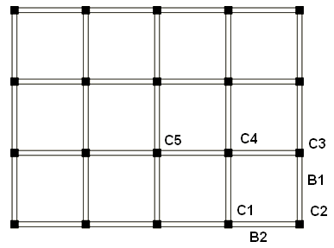

Fig. 1 Plan of the building

# **PUSHOVER ANALYSIS**

The push over analysis is done for the collapse analysis of the structure. It is a nonlinear static analysis. In this predefined loading pattern is distributed along the building height. These lateral forces increases until certain level of deformation reached or the total collapse of the structure. For this analysis the hinges are assigned to beams and columns. M3 hinges has been assigned to beams and PMM hinges for columns. PMM hinges are used to describe the post yield behavior of the column elements subjected to combined axial and biaxial bending conditions. Under incrementally increasing loads various structural elements may yield sequentially. Consequently, at each event, the structure experiences a loss in stiffness. Using a pushover analysis, a characteristic non linear force-displacement relationship can be determined. Performance of building has been classified into 5 levels, viz. (i) Operational (OP), (ii) Immediate Occupancy (IO), (iii) Damage Control (DC), (iv) Life Safety (LS) and (v) Collapse Prevention (CP). Occupancy, means the post earthquake damage state in which only very limited structural damage has occurred. There may be a few locations where the rebar will yield, but the crushing of concrete is not expected. Damage Control Performance Range means the continuous range of damage states that less damage than that defined for the Life Safety level, but more than that defined for the Immediate Occupancy level. Life Safety Performance Level means the post-earthquake damage state in which significant damage to the structure has occurred, but some margin against either partial or total structural collapse remains. Some structural elements and components have severely damaged, but this does not result in large falling debris hazards, either within or outside the building. Collapse Prevention Performance Level means the building is on the verge of experiencing partial or total collapse. Substantial damage to the structure has occurred, potentially including significant degradation in the stiffness and strength of the lateral-force-resisting system, large permanent lateral deformation of the structure and to more limited extent degradation in vertical-load-carrying capacity. The structure may not be technically practical to repair and is not safe for re-occupancy.

The performance of the structure is assessed by capacity spectrum as shown in Fig 3(a) obtained from pushover analysis. The intersection of the capacity spectrum and design spectrum known as performance point determined from the capacity curve gives the maximum elastic displacement. The base shear at performance point is 219.8kN and the corresponding displacement 0.0548 m. For the given structure the performance point is within the elastic limit.

1. Ground column removal
2. First column removal

Fig. 2 Comparison of displacement in different cases of column removal

# **COLLAPSE ANALYSIS**

In order to realize the progressive collapse of the building, the column members at ground and first storey are removed and subjected to incremental loading. The location of the columns which removed for collapse analysis is shown in Fig 1. Eleven cases are considered for the analysis. For the ground floor C1G, C2G, C3G, C4G, C5G cases and for first floor C1F, C2F, C3F, C4F, and C5F, cases are considered, where G refers to the ground floor columns and F for the first floor columns. CA refers to the case of intact building with no column removal.

To compare the nature of collapse for the above said eleven different cases the displacement versus load steps of push over analysis for are plotted. The most critical column failure observed from the Fig 2 is C2G i.e. the corner ground column. Capacity spectrum for the intact building case CA and C2G are shown in Fig 3. For CA case the demand curve intersects the capacity envelope at the elastic range but for C2G it meets beyond the elastic range. The demand curve intersects the capacity curve far beyond the elastic range, as illustrated in Fig 3b for C2G case implies very little reserve of strength and deformation capacity for the structure. Thus the structure will behave poorly during the imposed seismic excitation.

The base shear vs. roof displacement curve for model C1G, C2G C3G and CA is plotted from the results of pushover analysis (Fig 4). The plots for the 4 cases are initially linear but start to deviate from linearity as the beams and the columns undergo inelastic deformations. When the buildings are pushed well into the inelastic range, the curves become linear again but with a smaller slope. It is observed that the failure of a ground storey column in shorter direction of building for C3G has negligible effect on the load carrying capacity of structure, unlike the devastating effect on the structure due to localized failure of the corner column for C2G case. The base shear and displacement at performance point are 3796kN and 0.051m respectively for the C3G and is comparable with model CA. The base shear and displacement at performance point are 2273kN and 0.032m respectively for the C2G case. The reduction in base shear for C3G is 10 percent and for C2G is 46 percent when compared with CA model.

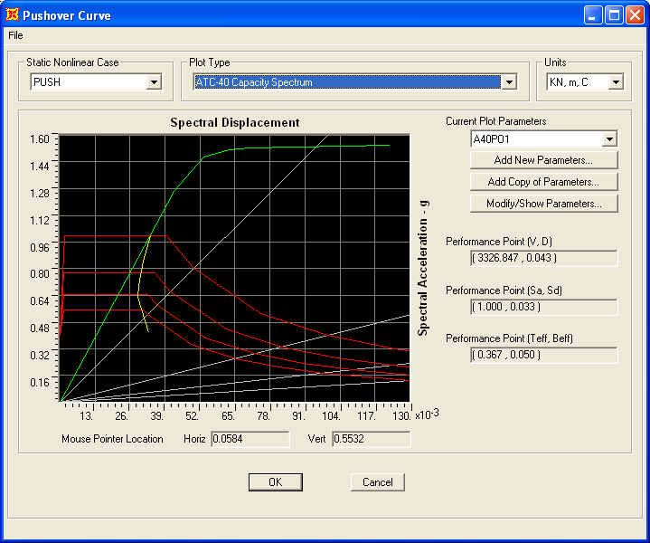

1. CA

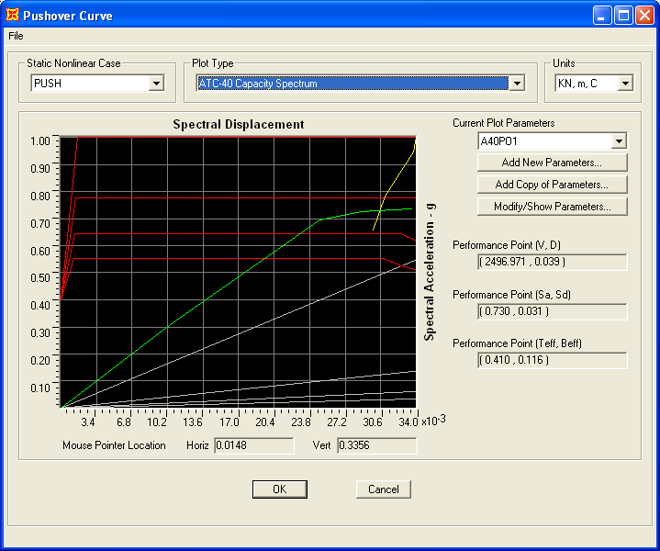

1. C2G

Fig 3 Capacity spectrum for different cases

Fig. 4 Shear forces Vs displacement

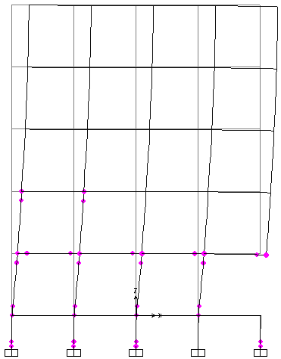

1. CA b) C2G

Fig. 5 Hinge formation at the performance point

The Fig 5 shows the plastic hinge formation of CA and C2G cases at the performance level. Plastic hinges formation starts with beam ends and base columns of lower stories, then propagates to upper stories and continue with yielding of interior intermediate columns in the upper stories. The hinge formation at performance point for the CA case shows that the amount of damage in the building is limited below IO level and for C2G case the the hinge formation is above the IO level. For the CA case the hinges are formed in the ground floor columns and for the C2G case the hinges formed upto the first storey columns at the performance level. This gives the information about the weakest member and it can be retrofitted. Accordingly the detailing of the member can be done in order to achieve the desired pattern of failure of members in case of severe earthquakes.

The result of progressive collapse showed that the failure of the corner columns are more critical and during sudden failure of this columns that load is transferred to the nearby beams. Since these nearby structural elements are not designed to carry this unprecedented load they will mostly fail and ultimately leading to total collapse of the structure. To reduce the impact of this kind failure the stiffness of the beams connected to the corner columns can be increased. It is observed that when the depth of the beams B1 and B2 as shown in Fig 1 is increased by 50 mm the base shear of the columns increases by 42.5 percent. For the C2G case the stiffness of B1 and B2 increased that case refers to C2G-A case. The displacement Vs steps in pushover analysis for C2G and C2G-A cases are shown in Fig.6. The base shear and displacement at performance point is 3956kN and 0.062m respectively for C2G-A model. The percentage increase in base shear of columns is 42.5 percent if the stiffness of B1 and B2 increases 27.1 percent.

Fig. 6 Comparison by changing stiffness

# **CONCLUSION**

The seismic performance of a building can be evaluated in terms of pushover curve, performance point, plastic hinge formation etc. It is concluded that pushover analysis is a successful method in determination of the sequence of yielding of the components of a building and possible mode of failure. The final state of the building after a predetermined level of lateral load sustained by the structure can be determined in the analysis. At the performance point, the resulting responses of the building are checked using certain acceptability criteria. The failure of corner column is critical and this affects the structure severely. The failure of corner column leads to the total collapse of the structure. To reduce the effect of this corner column collapse increase the stiffness of the nearby members according to the requirement. If the stiffness increases 27 percent the load carrying capacity can be increased by 43 percent.

# **REFERENCES**

[1] Abhay A. Kulkarni, Rajendra R. Joshi, Progressive collapse assessment of structure, *International Journal of Earth Sciences and Engineering*, *4(6),* 2011, 652-655

[2] Tarek H. Almusallam, H. M. Elsanadedy, H. Abbas, T. Ngo, and P. Mendis, Numerical analysis for progressive collapse potential of a typical framed concrete building, *International Journal of Civil & Environmental Engineering*, *10(2),* 2010, 40-46.

[3] A. Kadid, Boumrkik A, Pushover analysis of reinforced concrete frame structures, *Asian journal of civil engineering,9(1),*2008, 75-83.

[4] Mwafy A. M, Elnashai A S,Static pushover versus dynamic collapse analysis of RC buildings,*Engineering Structures, 23***,** 2001407-424.

[5] IS 456:2000 (2005). *Plain and reinforced concrete code of practice,* Bureauof Indian Standards, New Delhi

[6] IS 1893 Part 1(2006). *Criteria for earthquake resistant design of structures,* Bureau of Indian Standards, New Delhi