**American Journal of Engineering Research (AJER)**

e-ISSN : 2320-0847 p-ISSN : 2320-0936

Volume-3 pp-44-49

www.ajer.org

Research Paper Open Access

**Structural behavior of shear wall based on nonlinear**

**analysis**

Merin Mathews, Prabha C.

*Mar Athanasius College of Engineering, Kothamangalam, Kerala*

***Abstract: -*** Earthquake is one of the greatest natural disasters which cause immense damage to properties and human lives. As a part of an earthquake resistant building design, shear walls are provided in buildings to reduce lateral displacements under earthquake loads. The objective of the paper is to study the nonlinear behavior of a reinforced concrete shear wall under lateral earthquake load. For this a model of six storied RC structure is considered. The nonlinear behavior of the reinforced shear walls is then studied by static pushover analysis using the general purpose FE-program ANSYS. In the pushover analysis lateral load is stepwise increased from zero to twice the design earthquake load. From the analysis results a study of steel stresses, initial cracks, tension, compression and crushing cracks has been conducted. An attempt is then made to evaluate crack width to reflect the extent of damage.

***Keywords: -*** *Ansys , crack width, shear wall, steel stresses*

# **INTRODUCTION**

For medium and high-rise building the use of shear wall is indispensable, since they resist lateral loads very efficiently. Several modeling techniques are suggested for the evaluation of elastic and inelastic behavior of the lateral load resisting structures with shear wall. In the past elastic design has mainly been used in seismic design of concrete structures. Elastic analysis can give a good indication of the elastic capacity of structures but it cannot predict failure mechanisms and account for redistribution of force during progressive yielding. Nonlinear analysis gives a better understanding on how the structure will behave when subjected to earthquake, where the elastic capacity of the structure will be exceeded. Among the factors which influence the capacity of seismic energy dissipation of reinforced concrete shear walls, an important role is played by the door and window openings by their dimensions and positioning. For a safe design it is necessary to know the effects of openings in shear wall on stiffness as well as on seismic responses and behavior of structural system.

# **MODELING AND REINFORCEMENT DESIGN OF SHEAR WALL**

The model adopted is a reinforced concrete structure with G+5 stories. Height of each storey is 3m. Thickness of slab is 120mm. Live load intensity is taken as 3 kN/m2. The unit weight of brick masonry is taken as 20 kN/m3. Shear wall thickness is taken as 200mm.

Square columns - 450x450 mm; Beams - 250x250 mm; Concrete - M30; Steel - Fe500

Shear walls are provided at four external corners and inside shear walls with door openings are placed centrally. The inside shear wall with door openings are selected for analysis. Fig. 1 shows the plan and isometric view of the model selected.

Indian standard codes ARE 13920: 1983 and IS 1893:2002 do not provide any information regarding the crack pattern and crack width calculations in shear wall with openings. Eurocode 2: 2004 gives information regarding the crack width calculation in shear walls based on the steel stresses developed. Here the reinforcement calculations for the shear wall are based on the minimum reinforcement requirements as per Eurocode 2: 2004. [4] [5][6]

Based on this

(1)Vertical reinforcement of 0.04Ac is adopted.

(2)Horizontal reinforcement = 25% of the vertical reinforcement

Where Ac is the corresponding concrete sectional area

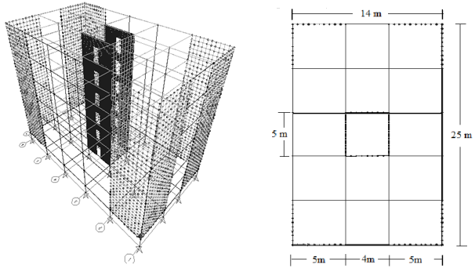

**Fig. 1Building model**

# **NONLINEAR STATIC PUSHOVER ANALYSIS**

Pushover analysis is a nonlinear static analysis. The nonlinear static procedure is a simple option for estimating the strength capacity in the post elastic range. A pattern of forces is applied to a structural model that includes nonlinear properties. This procedure involved applying a predefined lateral load pattern which is distributed along the building height. The nonlinear static pushover analysis is carried out using a general purpose finite element program Ansys [1]. The basic steps in the Ansys analysis are:

Preprocessing phase: Here model of the building is created graphically and sub divided into nodes and elements. Boundary conditions, initial conditions and loads are applied the model.

Solution phase: Here Ansys solves the defined numerical problem to obtain nodal results, such as displacement and stress values at different nodes.

Post processing phase: Here the important information is obtained and results are evaluated. [2]

**Element type**

***Solid 65***

The Solid 65 element is used to model the concrete in this analysis. The geometry, node locations and the coordinate system for the element is shown in Fig. 2. It simulates the elastic and plastic deformations that would happen in concrete and reinforcement inclusive of cracking until ultimately concrete crushing as the load is stepwise increased. The most important aspect of this element is the treatment of nonlinear material properties. The Solid 65 element is defined by eight nodes having three degrees of freedom at each node: translation in the nodal x, y and z directions. [3]

The reinforcement is modeled as real constants assuming a smeared model. The parameters selected to define the material properties of concrete and steel are given in table 1 and 2.



**Fig. 2 Solid 65 element**

**Table. 1 Concrete parameters**

|  |  |
| --- | --- |
| **Open shear transfer coefficient** | **0.1** |
| **Closed shear transfer coefficient** | **0.9** |
| **Uniaxial crushing stress** | **35 N/mm2** |
| **Uniaxial cracking stress** | **2.9 N/mm2** |
| **Biaxial crushing stress** | **42 N/mm2** |
| **Hydrostatic pressure** | **0.005** |
| **Hydrostatic biaxial crushing stress** | **50.75 N/mm2** |
| **Hydrostatic uniaxial crushing stress** | **60.375 N/mm2** |
| **Tensile crack factor** | **0.6** |

**Table 2. Steel parameters**

|  |  |
| --- | --- |
| **Poisson’s ratio for steel** | **0.3** |
| **Modulus of elasticity of steel** | **210000 N/mm2** |
| **Modulus of plasticity of steel** | **1.035 N/mm2** |
| **Yield point of steel** | **500 N/mm2** |

# **RESULTS AND DISCUSSIONS**

In the pushover analysis the lateral load is increased step-wise from zero to twice the calculated design load with an increment of 0.125 to see how the shear wall behaves if the lateral load exceeds the calculated design earthquake load. The analysis is carried out in two different ways i.e. analysis with material nonlinearity and analysis with a combination of both material and geometric nonlinearity. From the analysis results a comparative study of crack pattern, steel stresses, initial cracks, tension, compression and crushing cracks has been conducted. An attempt is then made to evaluate crack width to reflect the extent of damage.

***Crack pattern***

Cracking or crushing of an element is initiated once one of the element principal stresses exceeds the tensile or compressive strength of the concrete and the element thus becomes nonlinear. In a concrete element, cracking occurs when the principal tensile stress in any direction lies outside the failure surface. Crushing occurs when all principal stresses are compressive and lie outside the failure surface. The first crack appeared at diagonally opposite elements of second floor door openings (element num­bers 822 and 661). Fig 4 shows the crack pattern for normalized load = 0.25 (first crack) and normalized load = 1 (design load). The diagonal cracks represent the tension cracks, straight cracks represent flexural cracks and the circles represent the compression cracks or crush­ing of concrete

.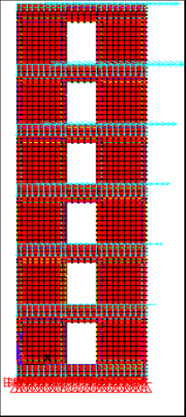 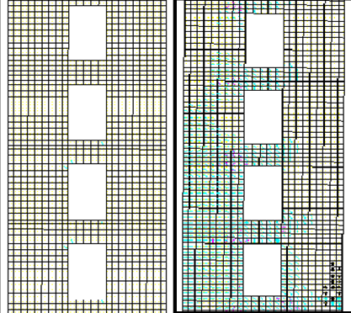

**Fig. 3 Model in Ansys Fig. 4 Crack pattern for NL=0.25 & NL=1**

***Steel stresses***

It is important to see the variation of stresses in the elements when the load is stepwise increased. The variation of steel stresses in element 822 & element 661 are examined and shown in Fig 5. It is observed that the steel stresses follow the same path until normalized load = 1. Beyond this, the analysis with a combination of both material and geometric nonlinearity showed failure of structure at normalized load = 1.375. Table 3 gives a comparative study of the steel stresses developed.



**Fig. 5 Steel stress Vs. Normalized load**

**Table 3. Steel stress comparison**

|  |  |  |
| --- | --- | --- |
| Element | Steel stresses MPa | |
| Material nonlinearity | Material & geometric nonlinearity |
| 661 | 500 (NL=1.375) | Failed (NL=1.375) |
| 822 | 500 (NL=1.375) | Failed (NL=1.375) |

***Crack width***

The crack pattern obtained does not give an idea about the extent of damage of the structures until the widths of the cracks are known. The steel stresses obtained from Ansys analysis is used to calculate the crack width based on EC-2.

Design crack width,

 (1)

where β - coefficient relating the average crack width to the design value

= 1.3 ( for wall thickness less than 300mm )

Srm = average final crack spacing

εsm = mean strain allowed

 (2)

where σs - stress in reinforcement.

σsr- stress in reinforcement under the loading conditions causing the first cracking.

β1- coefficient which accounts for the bond properties of the bar.

β2- coefficient which accounts for the duration of loading or repeated loading.

 (3)

where φ - bar size in mm.

k1 - coefficient which accounts for the bond properties of the bar.

k2  - coefficient which accounts for the form of strain distribution.

The calculations are made using above formulae and the crack width is plotted as a function of normalized load.

According to Eurocode 2 the crack width should not exceed 0.3mm to prevent corrosion of the reinforce­ment, which happens if the crack starts to leak. Crack 0.3mm wide is visible at a distance of about 2 m and it usually does not start to leak. For a crack of this size a light repair is usually needed. If the crack reaches 0.5mm or more the damage starts to get more serious. The concrete will start to leak and epoxy injection will be necessary. From the analysis results, in the element 822 and 661, the crack widths calculated were below 0.3mm in the case of shear wall with material nonlinearity. But for the same element the crack width exceeded the limit at normalized load of 1.125 in the case of analysis with a combination of material and geometric nonlinearity. Table 4 gives a comparison of crack widths obtained for different cases. Fig 6 shows the variation of crack width in both the elements.

**Table 4. Crack width comparison**

|  |  |  |  |  |
| --- | --- | --- | --- | --- |
| Element | Crack width (mm) | | | |
| Material nonlinearity | | Material & geometric nonlinearity | |
| 661 | 0.25 (NL=1) | 0.32 (NL=1.375) | Failed (NL=1.375) | 0.29 (NL=1) |
| 822 | 0.23 (NL=1) | 0.32 (NL=1.375) | Failed (NL=1.375) | 0.23 (NL=1) |



**Fig. 6 Crack width Vs. Normalized load**

# **CONCLUSIONS**

From the static pushover analysis it is possible to get information about crack pattern, initial cracks, tensile cracks and crushing. The first diagonal crack appeared at diagonally opposite elements of second floor opening (element 661 and 822) at normalized load = 0.25. Crack propagation pattern is obtained up to normalized load = 2 in the case of analysis with only material nonlinearity and up to failure load of 1.375 in the case of analysis with a combination of both material and geometric nonlinearity. A comparative study of the steel stress variation obtained from different analysis showed a similar stress pattern up to normalized load = 1. But the analysis showed failure of structure at normalized load = 1.375 in the case of a combination of material and geometric nonlinearity. From the steel stresses obtained, crack widths which are crucial in order to estimate the extent of damage are calculated based on Eurocode 2. The crack widths calculated showed a gradual increase based on an increase in steel stress. The crack width obtained for the two cases of analysis showed similar pattern with a slight higher value in the case of analysis with a combination of material and geometric nonlinearity. For both the cases the crack widths obtained are within the limit of 0.3mm even after the design load is exceeded. In the case of analysis with a combination of both material and geometric nonlinearity, at normalized load = 1.375 the crack widths obtained are 0.29 for element 661 and 0.23mm for element 822. The crack widths calculated by using the information from static pushover analysis seem to be promising and useful while designing and analyzing structures in seismic zones.

# **REFERENCES**

1. Antonio F Barbosa (2000), Analysis of reinforced concrete structures using ANSYS nonlinear concrete model, Computational Mechanics- New trends and applications.
2. Fanning P (2001), Nonlinear models of reinforced and post-tensioned concrete beams, Electronic Journal of Structural Engineering. Vol 2.
3. Greeshma S (2011), Analysis of flanged shear wall using Ansys concrete model, International Journal of Civil and Structural Engineering, Vol 2.
4. Eurocode 2 (2004), “Design of concrete structures, EN1992-1-1”, European Committee for Standardization, Brussels.
5. IS: 1893 (2002), Indian standard criteria for earthquake resistant design of structures, Bureau of Indian Standards, New Delhi.
6. IS: 13920 (1993), Indian standard ductile detailing of reinforced concrete structures subjected to seis­mic force, Bureau of Indian Standards, New Delhi.