American Journal of Engineering Research (AJER)
e-ISSN : 2320-0847 p-ISSN : 2320-0936
Volume-3 pp-39-43
www.ajer.org

Research Paper Open Access

Structural behaviour of high performance cement concrete slender shear walls under reverse cyclic loading

Seena.P, N.Ganesan, P.V.Indira
Department of Civil Engineering, National Institute of Technology, Calicut, India.

Abstract: - Behaviour of reinforced conventional concrete (CC) and reinforced high performance cement concrete (HPC) slender shear walls with aspect ratio three were investigated. The specimens were subjected to quasi static lateral reversed cyclic loading till failure. The high performance concrete (HPC) used was obtained based on the guidelines given in ACI 211.1 which was further modified by Aitcin. The longitudinal and transverse reinforcement ratios used in this study was 0.505%. The performance based parameters such as strength, stiffness degradation and ductility factor were obtained and the results are presented.

Keywords:- High performance concrete, Reverse cyclic load, Stiffness degradation, Slender shear wall, Ultimate load, Web reinforcement ratio.

- INTRODUCTION
The recent developments in the field of concrete represent a giant step towards making concrete a high-tech material [1].Over the last few years, the compressive strength of concrete used has increased dramatically and this spectacular increase is related to technological developments especially in the area of chemical and mineral admixtures. Due to the extraordinary dispersing action of the admixtures, it was possible to make concrete with high compressive strength and low water-binder ratio. The reduction in water-binder ratio results in a hydrated cement paste with a microstructure so dense and strong that coarse aggregate can become the concrete’s weak constituent [2]. The use of HPC in the construction of earthquake-resistant structures, long-span bridges, off-shore structures, nuclear power plants, and other mega-structures generally result in the reduction in size and hence leads to lighter cost-effective structures. This brand of concrete has enhanced compressive strength, stiffness and durability.

Shear walls are commonly used to resist the actions imposed on buildings due to earthquake ground motions. Shear walls are efficient, in minimizing earthquake damage in structural and non structural elements in a building. Shear walls can also be an effective solution to rehabilitate moderately damaged existing structures. One of the most common classifications of shear walls is with respect to their overall height-to-length ratio known as aspect ratio. Walls with an aspect ratio greater than two are usually referred to as slender shear walls and have a behaviour mainly dominated by flexure. Slender shear walls are quite common in tall buildings.

Review of literature indicates that numerous studies were conducted in the past to study the strength and behavior of normal concrete slender shear walls [3-7].However,only limited information is available on the strength and behaviour of reinforced high performance concrete (HPC) slender shear walls.Hence an experimental investigation was undertaken to evaluate the strength and behaviour of HPC slender shear wall and compare the same with reinforced conventional concrete (CC) slender shear wall under reverse cyclic loading.

- EXPERIMENTAL PROGRAMME
The experimental programme consisted of casting and testing of two slender shear walls made up of CC (CCW) and HPC (HPCW) under quasi static lateral reversed cyclic loading. The dimensions of specimens were 1500mm x500mm x 100mm. To provide fixity at the bottom, a base block of 100 mm wide 450 mm deep and 1100 mm long was constructed monolithically with the walls. The specimens were designed and detailed according to the seismic provisions of ACI 318-2008 [8].
2.1 Materials
The materials consist of (i) Ordinary Portland Cement (OPC) of 53 Grade conforming to IS: 12269-1987 (reaffirmed 2004) [9], (ii) fine aggregate confirming to grading zone III of IS: 383-1970 (reaffirmed 2002) [10] and having a specific gravity of 2.62, and (iii) coarse aggregate of 12.5 mm maximum size and having specific gravity of 2.81. The supplementary cementitious materials used were fly ash and silica fume. Fly ash was obtained from Mettur Thermal Power Plant, Tamil Nadu which conforms to ASTM C 618 [11] and Silica fume from ELKEM India (P) Ltd., Navi Mumbai conforms to ASTMC 1240 [12].Super plasticizer (Conplast 430) was used as chemical admixture. The reinforcing steel consisted of High Yield Strength Deformed bars (HYSD) of Fe 415 grade.

The longitudinal and transverse reinforcement consists of 8 mm diameter HYSD bars in the form of rectangular grid and placed in double layer. Because of a large overturning effects caused by horizontal earthquake forces, edges of the shear wall experience high compressive and tensile stresses. To avoid this, special boundary elements were provided at the edges. The main longitudinal reinforcement, provided in the boundary region was 4% over a width of 100 mm at the boundary of the element on each side. The longitudinal and transverse reinforcement provided in the wall web were 0.67% and 0.54% respectively. The nominal dimension of the specimens, together with the details of reinforcement is shown in Fig.1 \

2.2 Details of mix proportioning
The HPC used in this study was proportioned to attain a compressive strength of 60MPa. Mix design of HPC was done based on the guidelines given in ACI 211.1 [13] modified by Aitcin [14]. Conventional concrete (CC) was designed for a characteristic compressive strength of M60 grade as as per ACI 211.4 [15]. The HPC mix proportion for M60 concrete is given in Table 1.

Table 1. HPC mix proportions (kg/m³ )
Cement | Fly ash | Silica fume | Sand | Coarse aggregate | Water | Super plasticizer
405 | 110 | 45 | 600 | 1041 | 156 | 11.6

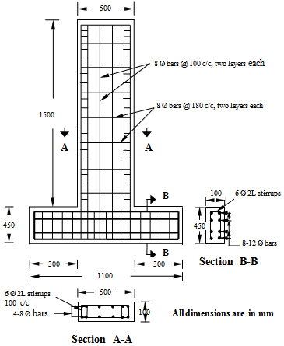

- TEST SET UP AND INSTRUMENTATION
Double acting hydraulic jack of capacity 100 kN was used for applying lateral reverse cyclic loads. Linear variable displacement transducer (LVDT) having 300 mm travel and a least count of 0.01 mm was used for monitoring the in plane horizontal displacement at the top of the wall. Strain gauges of 120 Ω gauge resistance and 1mm gauge length were used to measure strains in the longitudinal and transverse bars of the walls. A data acquisition system was used for monitoring steel strains continuously. Figs.2 shows the photograph of the test set up. The walls were subjected to quasi static lateral reversed cyclic loading till failure.
- RESULTS AND DISCUSSIONS
4.1 Overall Behaviour
Both walls were designed according to the seismic provisions of ACI 318-2008 exhibited a hysteretic behavior with flexural failure. Details of test results are given in Table 2. It may be noted from the table that the first crack load HPCW slender shear wall is 1.28 times higher than the CCW slender shear wall. The observed failure in these specimens were by flexure. Fig.3 shows the Photograph of tested specimens.

Table 2 Experimental results
Specimen | First Crack Load  (kN) | Ultimate Load  (kN) | Displacement corresponding to Ultimate Load  (mm) |  | Displacement at yielding of steel  (mm)
CCW | 6.70 | 50.01 |  | 46.65 | 24.93
HPCW | 8.60 | 50.05 |  | 41.65 | 17.8

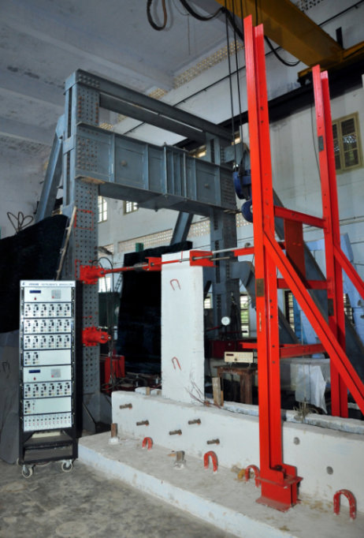 | 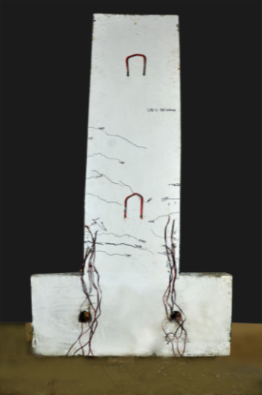 | 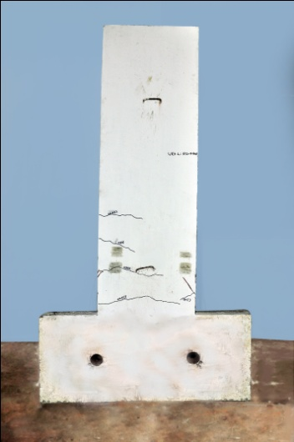
Fig.2. Photograph of the test set up | - CCW | (b) HPCW
 | Fig.3 Crack patterns of CCW and HPCW walls

4.2 Load deformation behaviour
It was observed that the lateral strength of both slender shear walls were almost same. It was also observed that HPCW exhibits less amount of lateral displacement than the CCW for the same type of loading, which indicates the increase in stiffness of wall. The Load-displacement hysteresis curves for the specimens are shown in Fig.4.

4.3 Stiffness Degradation
The lateral stiffness of the shear wall specimens were calculated from the base shear required for causing unit deflection at the top of the wall [16-17]. The stiffness in a particular cycle was calculated from the slope of the line joining peak values of the base shear in each half cycle. Fig.5 shows the comparison of stiffness degradation for CCW and HPCW shear wall specimens. From the figure it may be noted that the initial stiffness of HPCW shear wall is higher than the CCW shear wall.

Fig.4 Load-displacement hysteresis of specimens

4.4 Ductility Characteristic

Park [18] described the term ductility as the ability of a structure to undergo large amplitude cyclic deformation in inelastic range without a substantial reduction in strength. The displacements curresponding to maximum load and yield load are obtained from the envelope of load-deflection plot. The deflection corresponding to point of intersection of horizontal line through ultimate load and straight line through the initial linear part of the envelope curve gives the deflection at yield [19]. Cumulative ductility factor upto any point is the sum of displacement ductility factors attained in each cycle of loading upto the cycle considered. Fig.6 shows the comparison of cumulative ductility factor for the CCW and HPCW slender shear walls.

Fig.5 Comparison of stiffness degradation of CCW and HPCW slender shear walls |  | Fig.6 Comparison of cumulative ductility factor of CCW and HPCW slender shear walls

- CONCLUSIONS
This investigation leads to the following conclusion
- The first crack load of HPCW slender shear wall is 1.28 times higher than the CCW squat shear wall.
- HPCW shear walls exhibit less stiffness degradation compared to CCW shear walls. The initial stiffness of HPCW shear wall is 48.4 % higher than the CCW wall.
- The cumulative ductility factor of the HPCW slender shear wall is 27.40% higher than that of CCW slender shear wall.

REFERENCES
- Aitcin, P. C., “The durability characteristics of high performance concrete: a review”, Cement & Concrete Composites, Vol. 25, 2003, pp. 409-420.
- Aitcin, P. C., “Developments in the application of high-performance concretes”, Construction and Building Materials, Vol. 9, No. 1, 1995, pp. 13-17.
- Sittipunt C, Wood SL. Influence of web reinforcement on the cyclic response of structural walls. ACI Structural Journal1995; 92 (6): 1-12.
- Lefas ID, Kotsovos MD. Strength and deformation characteristics of reinforced concrete walls under load reversals. ACI Structural Journal 1990;87 (6): 716–26.
- Pilakoutas K, Elnashai AS.Cyclic behaviour of reinforced concrete cantilever walls.PartI: Experimental results. ACI Structural Journal 1995;92 (3): 271–81.
- Tasnimi AA. Strength and deformation of mid-rise shear walls under load reversal. Engineering Structures 2000;22 (4): 311–22.
- Massone L,Wallace JW. Load deformation responses of slender reinforced concrete walls. ACI Structural Journal 2004;101 (1): 103-13.
- ACI 318-08, “Building code requirements for reinforced concrete. American Concrete Institute, Farmington Hill,” Michigan, 2008.
- IS12269-1987 (reaffirmed 2004), “Specification for 53 grade ordinary portland cement”, Bureau of Indian Standards, New Delhi.
- IS 383-1970 (reaffirmed 2002), “Specification for coarse and fine aggregates from natural sources for concrete”, Bureau of Indian Standards, New Delhi.
- American Society for Testing and Materials (ASTMs) C 618-03, “Standard test method for coal fly ash and raw or calcined natural pozzolan for use in Concrete,” 2003.
- American Society for Testing and Materials (ASTMs) C 1240-05., “Standard specification for silica fume used in cementitios mixtures,”2005.
- ACI 211.1-91 (reapproved2009), “Standard practice for selecting proportions for normal, heavyweight, and mass concrete,”Farmington Hill, Michigan, American Concrete Institute.
- Aitcin, P,C., “High Performance Concrete,” London: U.K.,E & FN Spon; 1998.
- ACI 211.4R-08 “Guide for Selecting Proportions for High-Strength Concrete With Portland Cement and Fly Ash,” American Concrete Institute, Detroit, Michigan.
- Ganesan, N, Indira, P,V, and Shyju, P.T, “ Effect of ferrocement wrapping system on strength and behaviour of RC frames under reversed lateral cyclic loading”, International Journal of Experimental Techniques, January2010,Wiley‐Blackwell Publications:1-5.
- Devi,G.N, Subramanian,K, Santhakumar, A.R, “Experimental investigations on reinforced concrete lateral load resisting systems under lateral loads”, International Journal of Experimental Techniques, Wiley‐Blackwell Wiley‐Blackwell Publications,59-73.
- Park R. Evaluation of ductility of structures and structural assemblages from laboratory testing. Bulletin of the New Zealand National Society for Earthquake Engineering September 1989;22(3).
- Ganesan N,Indira PV,Shyju PT. Hysteretic behaviour of RC frames retrofitted at two different levels of distress using ferrocement wrapping technique. International Journal of Earth Sciences and Engineering February2010;l3(1):100-07.

