American Journal of Engineering Research (AJER)
e-ISSN : 2320-0847 p-ISSN : 2320-0936
Volume-3 pp-34-38
www.ajer.org

Research Paper Open Access

Manually recycled coarse aggregate from concrete waste− a sustainable substitute for customary coarse aggregate

Praveen Mathew¹, Vilma Baby², Dipak Kumar Sahoo³, Glory Joseph³
¹ Research Scholar, Civil Engineering Department, School of Engineering,
Cochin University of Science and Technology, Kochi, Kerala, India
²M-Tech student, Computer Aided Structural Engineering, Civil Engineering Department,
Mar Athanasius College of Engineering, Kothamangalam, Kerala, India
³School of Engineering, Cochin University of Science and Technology, Kochi, Kerala, India

Abstract: - Using manually recycled coarse aggregate obtained from waste concrete to manufacture fresh concrete is a highly sustainable option for the developing countries in order to beneficially dispose off old concrete structures, preserve the depleting stock of natural resources, utilize cheap unemployed labour and reduce the carbon footprints of new constructions. The test results from the limited laboratory experiments on recycled coarse aggregate of granite origin suggest that the quality of concrete made out of manually recycled coarse aggregate in terms of compressive, flexural and splitting tensile strength is comparable to that of concrete made out of natural coarse aggregate of granite origin. Workability of manually recycled coarse aggregate concrete was found to be less but could be improved by using super plasticizers. The nominal reduction in strength and additional cost of manual recycling could be offset by savings in the cost of disposal of waste concrete and procurement of new aggregate and most importantly by reduction in the carbon footprints of new constructions which might be rewarding for building owners with expected changes in the state policy in future.

Keywords: - Equivalent mortar volume, Manually recycled coarse aggregate, Structural applicability, Sustainability

INTRODUCTION
These days a huge amount of concrete waste is produced due to the old structures giving up for new one. Its disposal as wastes or land fill even at this stage of shortage of resources is to be viewed seriously. The idea of using recycled (concrete) coarse aggregate (RCA) as an alternative to conventional natural coarse aggregate for fresh concrete is born out of the necessity to address this shortage of natural material and to dispose off the demolished concrete waste. Unfortunately, despite its vast potential application, RCA concrete, i.e., concrete made from coarse recycled concrete aggregate or RCA, is yet to receive its due level of acceptance as a structural material in the construction industry due to apparent concerns related to its strength and durability [1]. However, recent studies have shown that the inferior strength and durability of RCA concrete noticed in the past are not its intrinsic properties but are rather attributable to improper mix proportioning methods adopted by the earlier researchers. If RCA is treated as conventional natural coarse aggregate (NCA) and if concrete is proportioned accordingly, the residual mortar attached to the coarse aggregate particles will cause the total mortar volume to increase leading to an inferior mix.
Now, with the advanced recycling methods and a novel method of mixture proportioning called the equivalent mortar volume (EMV) method [2], the RCA concrete is found to meet the current codal requirements for concrete. In the EMV method, RCA is treated as a two-phase composite material comprising of residual mortar and original virgin aggregate, therefore when proportioning the mix, the volume fraction and the relevant properties of each phase are to be accounted separately.

MIX PROPORTIONING WITH RCA
In the new mixture proportioning method for RCA concrete developed by Fathifazl et al. [2, 3], RCA is treated as a two-phase material comprising of residual mortar and natural aggregate. If conventional methods are used for proportioning of RCA concrete, then due to the residual mortar attached to the virgin aggregates, the actual quantity of coarse aggregate in the concrete gets effectively reduced which affects the strength and durability of concrete. Hence, the residual mortar attached to the recycled coarse aggregate particles is treated as a part of the total mortar volume in the RCA concrete. Therefore, the concrete mixture, proportioned using this method with RCA, has less new fine aggregate and new cement than the equivalent natural aggregate concrete mixture proportioned using the conventional method making the new concrete a sustainable one. RCA concrete thus proportioned was found to have good or even superior fresh and hardened physical and mechanical properties when compared with natural coarse aggregate (NCA) concrete. Here the RCA was produced from chunks of concrete from a 30 year old building by crushing manually and then by grading.
In the present investigation, for using RCA instead of NCA as coarse aggregate in concrete, the authors have modified the Indian Standard mixture proportioning method, IS 10262: 2009 [4], by adapting the basic philosophy of Fathifazl’s EMV method. The RCA concrete was made using this modified IS 10262 method and RCA was used in combination with manufactured sand as fine aggregate (FA) obtained by crushing rocks of granite origin which falls in Zone II grading of sand according to IS 383: 1970 [5].
To determine the residual mortar () in RCA [2], three samples of blended aggregates were taken with a sample size of approximately 1000 g. After drying the samples for 24 hours at 105ºC, the oven-dried samples were immersed in sodium sulphate solution with a concentration of 26% by weight for 24 hours. The samples in the immersed state were subjected to 5 cycles of freezing and thawing, i.e., by keeping it in an oven at 80ºC for 8 hours and below 0ºC overnight in a freezer. After the fifth cycle, the solution was drained out and the aggregate was washed with tap water over 4.75 mm IS sieve. The washed aggregates were weighed after drying it in oven for 24 hours at 105ºC. The content in percentage was calculated as shown in (1).

(1)
where = Initial oven dry weight of RCA sample
= Oven dry weight of RCA sample after removing the residual mortar

2.1 Aggregate properties

The specific gravity, water absorption and fineness modulus of the coarse and fine aggregates were determined using the standard testing procedures in accordance with relevant Indian Standard (IS) codes. The physical properties of aggregates are as shown in Table1, whereas the fine aggregate (FA) used is manufactured sand (M-sand). For the present study, M25 and M30 mix has been selected as it conforms to normal reinforced concrete works according to the IS 456: 2000 [6]. The cement used was 53 grade ordinary Portland cement of single origin and with an average specific gravity of 3.1.

Table 1 Physical properties of the Aggregate
PHYSICAL PROPERTIES
Aggregate type | Specific gravity | Water absorption (%) | Fineness modulus
NCA | 2.79 | 1.21 | 2.39
RCA | 2.59 | 5.32 | 3.27
FA | 2.65 | 1.13 | 3.91

The NCA concrete was proportioned according to IS 10262: 2009 [4] and RCA concrete which involves the replacement of natural coarse aggregate by RCA, was proportioned according to the modified IS 10262 method.
The maximum permissible residual mortar content, RM_{max} for using the RCA is 33.21% according to the specific gravity of RCA and NCA, which is slightly less than the RM content of RCA obtained which amounts to 35.6%. Therefore fresh NCA has to be supplemented with RCA to compensate for the deficiency of virgin aggregates.

2.2 Material proportions
The quantity of materials for one cubic meter of RCA concrete compared with that of NCA concrete are shown in Table 2. Since the new cement content for RCA concrete was obtained less exhibiting a poor workable mix, the minimum cement content was fixed as per the codal provision for the respective grade. Slump of the resulting concrete was found to be less than 6mm. Hence to avoid a harsh mix, water reducing agent @ 0.6% by weight of cement was added.

Table 2 Comparison between the ingredients of RCA & NCA concrete
INGREDIENTS (kg) FOR 1 m³ OF CONCRETE
Ingredients | M25 |  | M30
 | NCA | RCA | NCA | RCA
Cement | 380 | 300 | 410 | 320
FA | 695 | 370 | 674 | 355
CA | 1243 | RCA-907  NCA-392 | 1258 | RCA-917  NCA-396.4
Water | 171 lit | 116 lit | 164 lit | 110 lit
Water reducer | - | 1.8 lit | - | 1.92 lit

For each mix, three 150 mm size cubes were cast and kept moist for 28 days to determine the compressive strength. To determine the splitting tensile strength and the elastic modulus, 150300 mm cylinders were cast and to determine the flexural strength, 100100500 mm prism were cast. Specimens, cured in water, were tested after removal from water and while they were still in wet and surface dry condition.

RCA FOR STRUCTURAL CONCRETE
As RCA is a two-phase material comprising of residual mortar and original virgin aggregate, while proportioning a concrete mix with RCA, the volumetric ratio and relevant properties of each phase must be accounted separately [2]. The total mortar volume in RCA concrete is considered as the sum of the residual and fresh mortar fractions. Concrete proportioned using this method has been found to have good structural properties compared with an equivalent conventional concrete with NCA and with the same volume of mortar as the total mortar volume in RCA concrete. Table 3 shows the average properties of RCA concrete in comparison with that of NCA concrete. Ultrasonic pulse velocity (UPV) tests were also conducted on cube specimens to ascertain its quality with regard to density, in comparison with the cube compressive strength.

Table 3 Properties Of Rca And Nca Concrete
PROPERTIES OF CONCRETE (N/mm²)
Properties | M25 |  | M30
 | NCA | RCA | NCA | RCA
Compressive strength | 34.6 | 29.3 | 39.0 | 32.2
Flexural strength | 5.2 | 6.2 | 5.9 | 6.4
Splitting tensile strength | 3.1 | 2.8 | 6.8 | 4.2
Young’s Modulus | 1.85x10⁴ | 1.5x10⁴ | 2.37x10⁴ | 3.05x10⁴
Average UPV values (km/s) | 4.95 | 4.65 | 5.03 | 4.74

It is evident from Table 3 that, with the new mix proportioning method, the properties of NCA and RCA concrete are comparable. The results of RCA concrete shows that the previous concern on structural quality of RCA concrete is over. Even though the compressive strength obtained for RCA, both for M25 and M30 grades are less in comparison with the conventional concrete, the other properties in relation with its compressive strength are supportive. The ultrasonic pulse velocity test conducted on both NCA and RCA concrete bear good results and all the values are above 4.5 km/s which falls in excellent rating.
The stress strain curves where obtained by testing the cylinder specimens with compressometer attached with 3 equally spaced dial gauges with an aim to measure deflection in three directions which would give a more valid result. Figure 1 shows the stress-strain curve for both RCA and NCA specimens.

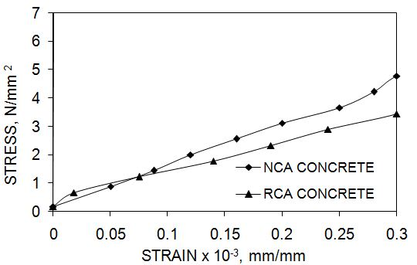 | 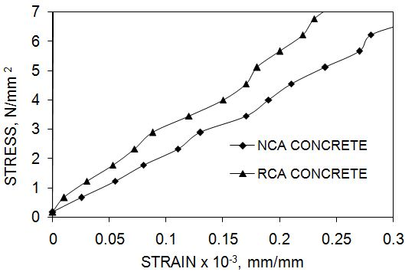
(a) M25 grade concrete | (b) M30 grade concrete
Fig. 1 Stress-strain curves for RCA & NCA

From figure 1(b), it is seen that RCA concrete specimens have outrun the NCA concrete specimens regarding stiffness. But for M25 concrete both NCA and RCA has shown almost identical stiffness, RCA being a little lower, figure 1(a).

3.1 Durability aspect
With an attempt to study the durability characteristics of RCA concrete in various aggressive environment, some limited studies were conducted on NCA and RCA specimens. Concrete cube specimens of both NCA and RCA were doused in sulphate (7.5% MgSO₄ & CaSO₄) and acidic (3% H₂SO₄ with pH 4) solutions and its weight loss, UPV value etc. at 90 and 120 days were observed. The quality of concrete at 90 and 120 days in various solutions are tabulated in table 4.

Table 4 Quality of Concrete- Suggestive Of Durability
Mix ID |  | M25 |  |  |  | M30
Type |  | NCA |  | RCA |  | NCA |  | RCA
No. of days |  | 90 | 120 | 90 | 120 | 90 | 120 | 90 | 120
Reduction in UPV km/s | MgSO₄ | 0.31 | 0.33 | 0.19 | 0.21 | 0.08 | 0.11 | 0.05 | 0.07
 | CaSO₄ | 0.3 | 0.32 | 0.04 | 0.06 | 0.2 | 0.27 | 0.04 | 0.08
 | H₂SO₄ | 0.63 | 0.74 | 0.48 | 0.58 | 0.48 | 0.6 | 0.38 | 0.47
Weight loss %-age | MgSO₄ | 0.52 | 0.56 | 0.17 | 0.25 | 0.38 | 0.53 | 0.13 | 0.15
 | CaSO₄ | 1.66 | 2.1 | 0.11 | 0.13 | 0.96 | 1.01 | 0.08 | 0.13
 | H₂SO₄ | 1.66 | 2.06 | 0.28 | 0.32 | 1.69 | 2.01 | 0.21 | 0.25

From table 4, on comparing the values of both NCA and RCA at 90 and 120 days in three stated solutions, both weight loss and reduction in UPV were obtained less for RCA. This may be due to several reason, that the residual mortar which is incorporated in the total mortar volume is of completely hydrated one and much less water has been utilized for mixing up of the materials. But on reducing water content the workability will be seriously affected due to which water reducers shall be used, the additional expense which can be compensated with the savings in cement and natural aggregate. About 10 to 20 % cost savings can be achieved eventhough admixtures are used. Figure 2(a)-(c) shows the compressive strength of NCA and RCA concrete cubes at 120 days of dousing in three specified solutions.

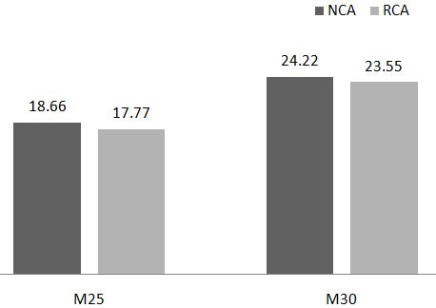 | 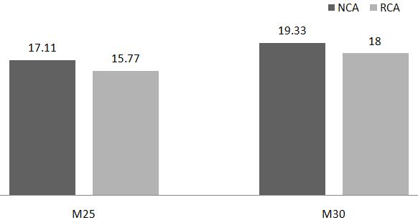
(a) Doused in MgSO₄ | (b) Doused in CaSO₄
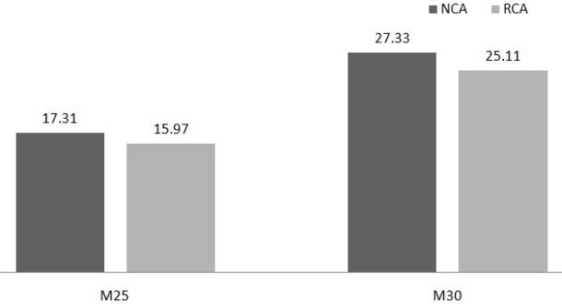
(c) Doused in H₂SO₄
Fig. 2 Compressive strength of concrete cubes in various solutions at 120 days

The compressive strength at 120 days of dousing in chemical solutions obtained for RCA is found comparable to that of NCA.

CONCLUSION
The use of recycled aggregates in fresh concrete has been in use for over many years. But due to the apparent concern over its structural property, the use of it is restricted to some non structural applications and in less important structures. But on modifying the mix proportion by accounting the attached mortar to virgin aggregates in order to decide fresh mortar volume, the hardened properties of RCA concrete can be measured at par with conventional concrete. The results of laboratory tests on cubes, cylinders and prisms made with recycled (concrete) coarse aggregate concrete agree with this. With some limited studies on its durability, RCA concrete has shown a superior performance than the conventional concrete. Hence the previous concern over RCA has almost melted up.

REFERENCES
- D K. Sahoo, B. Singh, P. Bhargava Strut efficiency factors for structural concrete made from coarse recycled concrete aggregates, Journal of Structural Engineering, 37(1), 2010, 49-54.
- G. Fathifazl, A. G. Razaqpur, O. B. Isgor, A. Abbas, B. Fournier, S. Foo, New Mixture Proportioning Method for Concrete Made with Coarse Recycled Concrete Aggregates, Materials in Civil Engg., ASCE, 21(10), 2009, 601-611.
- G. Fathifazl, A. G. Razaqpur, O. B. Isgor, A. Abbas, B. Fournier, S. Foo, Proportioning concrete mixtures with recycled concrete aggregates, Concrete International, 32(03), 2010, 37- 43.
- IS 10262. Concrete mix proportioning- guidelines, Bureau of Indian standards, New Delhi, India, 2009.
- IS 383. Specification for coarse and fine aggregates from natural sources for concrete, Bureau of Indian standards, New Delhi, India, 1970.
- IS 456. Plain and Reinforced concrete – Code of practice, Bureau of Indian standards, New Delhi, India, 2000.

