American Journal of Engineering Research (AJER)
e-ISSN : 2320-0847 p-ISSN : 2320-0936
Volume-XX, Issue-XX, pp-XX-XX
www.ajer.org

Research Paper Open Access

Free vibration analysis on FRP bridges

Aswani M. Panicker¹, Alice Mathai¹
¹(Department of Civil Engineering, Mar Athanasius College of Engineering, India)

Received Manuscript: XX-XX-XXXX
Accept Manuscript: XX-XX-XXXX
Published Manuscript: XX-XX-XXXX

ABSTRACT : Fibre Reinforced Polymer Composites (FRP) are gradually gaining acceptance from civil engineers, mainly in the field of bridge engineering. The dynamic amplification factor is related to the fundamental frequency of the bridge. The study of free vibration is therefore, important to check whether the bridge will be safe under traffic induced vibrations. The paper presents the free vibration analysis of an FRP box girder bridge using the finite element software, ABAQUS. The bridge model consists of 18mm thick laminated FRP box girders with an outer layer of laminate winding all the box girders together. The deck of the bridge made of chopped FRP is supported on the girders. It was found that the natural frequency of the FRP bridge and the vehicular induced vibrations may cause possibility of resonance. Therefore, it is always significant to carry out the free vibration analysis of FRP bridge for its design.
Keywords -free vibration analysis, natural frequency, mode shapes, chopped frp

INTRODUCTION
FRP composites have been used in aerospace and marine applications for over 50 years. Most of the bridges in the world are either repaired or in the stage of repairing. This indicates the necessity of development of new structural elements and construction technologies, for use in bridges exposed to aggressive environmental conditions, by using alternative materials, more durable and resistant to corrosion like FRP. Its advantages over conventional materials like its high tensile strength to weight ratio, ability to be moulded to various shapes, corrosion resistance, lower lifecycle cost, good durability and fatigue strength make FRP composite, a good alternative for innovative construction. The reduction in the durability of conventional bridges when exposed to aggressive environment has led to the replacement of concrete decks as well as retrofitting of bridge parts using FRP. The use of FRP could reduce the high self weight , improve the corrosion and impact resistance.

Literature Review
Chiewanichakorn et al. (2003) [1] replaced a deteriorated concrete deck by an FRP bridge deckand it allowed for higher live load on the bridge. Chandrashekhara K.et al. (2003) [2] subjected an FRP bridge model to fatigue load of 2 million cycles corresponding to AASHTO requirements and found no loss in stiffness and strength. Kim et al.(2003) [3] designed and analyzed GFRP deck for highway bridges and assessed several cellular tube sections to obtain a viable cross sectional profile for the deck. Roy R. J. et al. (2005) [4]designed and fabricated a bridge deck slab made of fiber reinforced polymer composite materials and the prototype deck subjected to static loading using hydraulic jacks supported a total of 515kN (twice the design service load) without any fracture, cracking or damage to the deck elements. K.A. Harries and J. Moses (2007)[5] studied the effect on superstructure stresses on replacing a RC deck with GFRP deck and found that GFRP exhibit reduced composite behavior and reduced transverse distribution of forces compared to RC decks. Almansour H. and Cheung M.S. (2010) [6] proposed an iterative performance based multi-scale analysis and design approach for all-advanced composite bridge superstructure. Nicolas J. Lombardi and Judy Liu (2010) [7] proposed Glass fiber-reinforced polymer or steel hybrid honeycomb sandwich concept for bridge deck applications and proved that the stiffness of the commercial GFRP honey comb sandwich panel can be increased by the inclusion of steel within the cross section. A. Bali et al. (2011) [8] conducted a case study of a 3 span RC bridge in a strong seismic activity area before and after its repair by the application of carbon fiber composites and found that the application of composite material to strengthen the structure increased the transverse rigidity of the structure and thus its modal frequency.

need for the study
Dynamic behavior of an FRP bridge is an area which require more research and design recommendations. The DAF is related to the fundamental frequency of the bridge. The most significant traffic-induced vibrations are a combination of many modes, but it is easier for design code purposes to relate the dynamic load allowance to the fundamental frequency. Most modern highway bridges were found to have fundamental frequencies in the range of 2 to 5 Hz, corresponding to the resonant frequencies of commercial vehicles. Therefore, it is important to study the free vibration of bridges.

Free vibration analysis

1.Geometry of FRP bridge
In this analysis, the bridge model was taken from the journal paper by Dr.HushamAlmansour published in 2010 .[6] Bridge superstructure is formed from laminated FRP box girder and chopped FRP top surface layer. The bridge cross section is shown in Fig.1.

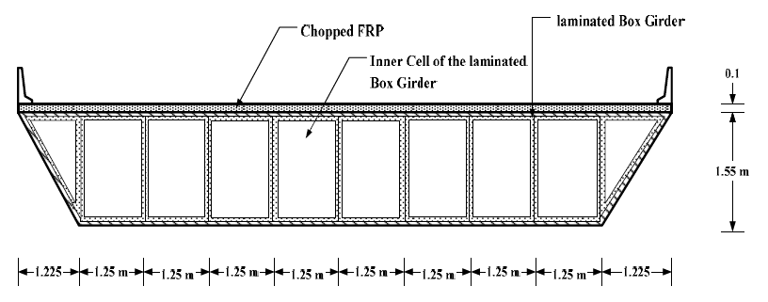
fig. 1 Deck section of the simply supported two lane FRP bridge.

The bridge deck section consists of a series of inner FRP box cells surrounded by an outer FRP binding box. The 24.75 m long and 12.45 m wide FRP bridge was modeled in ABAQUS.
Homogenized material properties of chopped FRP of the deck slab are,
- Modulus of elasticity = 9.32GPa
- Poisson’s ratio = 0.276
- Ultimate strength = 139MPa
The lamina is formed from E-glass fiber and vinyl ester matrix (GFVM). Table 1 gives the mechanical properties of the lamina (GFVM) used in the FRP box girders. Table 2 gives the orientation and number of lamina layers in the 18mm thick laminate.

Table 1 Mechanical properties of the lamina- E-Glass fiber and Vinyl ester Matrix
Longitudinal modulus of elasticity, E₁ |  | 24.5GPa
Transverse modulus of elasticity, E₂ | 23.8GPa
Transverse out of plane modulus of elasticity, E₃ | 11.6GPa
In-plane Poisson’s ratio | 0.11
In-plane shear modulus | 4.7GPa
Longitudinal tensile strength | 433MPa
Longitudinal compressive strength | 335MPa
Transverse tensile strength | 386MPa
Transverse compressive strength | 335MPa
In-plane shear strength | 84MPa

Table 2 Lamina alignment
Lamina layer | Lamina orientation(Degree)
 | Inner laminate | Outer laminate
1 | -10 |  | -10
2 | 30 |  | 45
3 | 10 |  | 10
4 | -30 |  | -45
5 | 10 |  | 10
6 | 45 |  | 90
7 | 45 |  | 90
8 | 10 |  | 10
9 | -30 |  | -45
10 | 10 |  | 10
11 | 30 |  | 45
12 | -10 |  | -10

2.Modeling
In ABAQUS, an FRP bridge of 24.75m long and 12.45m wide was modeled with a laminate of 18mm thick with 12 layers of lamina in it. The bridge was modeled as a three dimensional, deformable structure. The modeling of the bridge was done mainly using four modules of ABAQUS, viz , the Part module, the Property module, the Assembly module and the Interaction module. The bridge was modeled as five parts, the deck, top flange, bottom flange, inclined web and web in the Part module. The cross section of each part was sketched and extruded to the desired length. In the Property module, the material properties were defined and assigned. The ply count and the lamina orientations were given with the help of the composite layup manager. Each part has being assigned a local coordinate system and the fiber orientations were assigned with respect to the local coordinate system. In the Assembly module, all the parts were created as instances and assembled together to form the bridge structure. The free vibration analysis was done by selecting the frequency option in the linear perturbation analysis in the step module of ABAQUS. In the Load module, various loading conditions can be specified and the boundary conditions were given for the bridge as simply supported. In the Interaction module, each of the parts was tied to the adjacent parts for the structure to act as a continuum and also to avoid the relative motion between the surfaces. The model was meshed using a solid isoparametric element named, C3D8R. It is an eight-noded linear brick element with reduced integration and hourglass control. The meshed model of the bridge is shown in the Fig. 2.

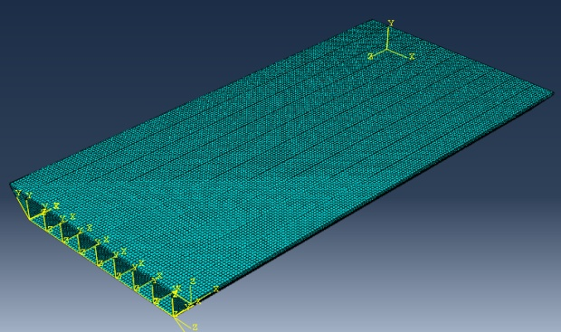
fig.2 Mesh model of frp bridge in ABAQUS

The analysis was run and the results were obtained in the visualization module.

Results and discussion
The first three natural frequencies were 4.1509Hz, 6.092Hz and 6.7058Hz under free vibration analysis for the two lane bridge.The first three mode shapes of the bridge subjected to free vibration are shown in Figs.3-5.

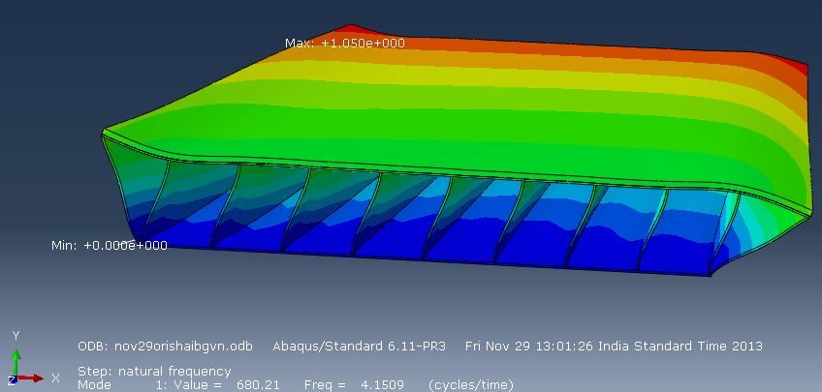
fig. 3First mode shape of two lane frp bridge
fig. 4Second mode shape of two lane frp bridge
fig. 5Third mode shape of two lane frp bridge

Conclusion
In the free vibration analysis of a bridge, the natural frequency indicates the frequency of vibration or excitation which can cause resonance in the bridge structure. Here, the first natural frequency of two lane FRP bridge fall in the range of 4-7Hz. The study of free vibration is important to check whether the bridge will be safe under traffic induced vibrations. Also, to define a dynamic amplification factor for the FRP bridges, it is important to find the fundamental frequency of the bridge. The vibrations caused by vehicular loads in bridges usually fall in the range of 5-80Hz as observed in the literature.
Therefore, it is evident that the obtained frequency is not much far from the frequency induced by traffic. The natural time period of the bridge falls within the range of earthquake excitation time period (0-10Hz), still, intensive study of earthquake effects on bridge is not required as the effect of earthquake is not transferred to the deck through pillars, since the deck is on rollers or on base isolators.

References
- Chiewanichakorn M. ,Aref, A.J. and Alampalli S. , (2003), “Failure Analysis of a Fiber-reinforced Polymer Bridge Deck System”, ASTM Journal of Composites and Technology, Vol. 25,No.2,119-128.
- Chandrashekhara K., Prakash K., Antonio Nanni,(2003) “Structural performance of a FRP bridge deck”, Construction and Building Materials, Vol.18, 35–47.
- Kim S.M, Kim H.Y.,(2003) “Design of pultruded GFRP Deck for highway bridges”, ECI conference on advanced materials for construction of bridges, buildings and other structure.
- Roy R.J, Debaiky A.S., Borazghi H., Benmokrane B.(2005), “Glass Fibre Reinforced Polypropylene Bridge Deck Panel Design”, Fabrication and Load Testing,33rd Annual General Conference of the Canadian Society for Civil Engineering,1-9.
- K.A. Harries and J. Moses,(2007), “Replacing a composite RC bridge deck with an FRP deck– the effect on superstructure stresses”, Asia-Pacific Conference on FRP in Structures.
- Almansour H., Cheung M.S.(2010), “Structural performance of laminated FRP box girder bridge deck compared to slab on prestressed concrete girder bridge”, The 8th Canada Japan Joint Workshop on Composites, Montreal, Canada, 1-32.
- Nicolas J., Lombardi, Lui (2011), “Glass fibre reinforced polymer/ steel hybrid honey comb sandwich concept for bridge deck applications”, Composite structures, Vol.93, 1275-1283.
- A.Bali, M. Abdessemed, S. Kenai, A. Kibboua,(2011)“ Dynamic analysis of a bridge repaired by CFRP: Experimental and numerical modeling”, Construction and Building Materials,25(2011),1270-1276.
- Isaac M. Daniel, OriIshai (2006), Engineering Mechanics of Composite Materials.New York, Oxford, Oxford University Press, Second Edition.
- ABAQUS Cae User’s manual.

