American Journal of Engineering Research (AJER)
e-ISSN : 2320-0847 p-ISSN : 2320-0936
Volume-XX, Issue-XX, pp-XX-XX
www.ajer.org

Research Paper Open Access

Behaviour of concrete structures under fire - a comparative study between IS 456: 2000 and finite element software ANSYS

Boby Jacob¹, Aneesha Balaji² and Elson John³
¹(Department of Civil Engineering, M. A. College of Engineering, M. G. University, India)
²(Department of Civil Engineering, Viswajyothi College of Engineering, M. G. University, India)
³(Department of Civil Engineering, M. A. College of Engineering, M. G. University, India)

Received Manuscript: XX-XX-XXXX
Accept Manuscript: XX-XX-XXXX
Published Manuscript: XX-XX-XXXX

ABSTRACT : Unwanted fire has become one of the greatest threats to buildings. Concrete has very good behavior under fire due to its low thermal conductivity and non-combustibility. Concrete act as a protective cover to steel reinforcement and thus reinforced cement concrete shows good behavior under fire. However, there is a major problem caused by elevated temperatures that is the break of concrete masses from the surface of the concrete element “spalling phenomenon". A finite element approach in ANSYS software, for tracing the behavior of reinforced concrete elements exposed to fire is presented. Design charts for various structural elements have been developed.
Keywords –design charts, fire resistance, spalling, , temperature profile
1. Introduction
Normal Fire impacts reinforced concrete (RC) members by raising the temperature of the concrete mass. This rise in temperature reduces the mechanical properties of concrete and steel. They might also result in explosive spalling of surface pieces of concrete members. However, when it is subjected to prolonged fire exposure or unusually high temperatures, concrete can suffer significant distress. But large temperatures can reduce the compressive strength of concrete so much that the material retains no useful structural strength. Considerable amount of research has been directed towards the development of numerical methods which enable the behaviour of a structure to be predicted by much less expensive computer simulations. As per IS 456: 2000 a structure or structural element required to have fire resistance should be designed to possess an appropriate degree of resistance to flame penetration, heat transmission and failure. The chart presented in this work can be used to find the fire resistance of reinforced concrete beams, columns and slabs with an accuracy that is sufficient for practical purpose.
2. Significance of the Study
The behaviour of reinforced concrete structural elements is studied extensively in recent years but it is all highly research oriented. Therefore, it is necessary to generalize and validate such structural models and been analysed using common engineering packages such as ANSYS. The temperature distribution charts which are available in codes of other countries are not in Indian codes. Experimental fire tests are very expensive and also it has many limitations. It is not possible to undertake fire resistance tests for all possible fire scenarios. So recently the research has focused mainly on the development of analytical methods for understanding the behaviour of structural buildings exposed to fire. Tabulated data in the codes may be computed either by experimental results or by calculation methods. These charts are only some design aids.
3. Thermal Analysis of Beam with ANSYS
Beam of size 200mm x 400mm is modeled in ANSYS and the temperature profile is plotted by exposing the beams to ISO 834, standard fire curve(Fig.1) (ISO 834, 1975). From the temperature profiles, the required cover for a particular beam can be found out based on different failure criteria. For particular fire resistance time, the required cover thickness for the flexural members can be found out. The analysis results were compared with IS 456: 2000.

Fig. 1 ASTM E119 and ISO 834 time-temperature curves
3.1 Failure criteria
The model generates the critical output parameter, temperature at various fire exposure times. This output parameter is used to check against predefined failure criteria. At every time step, each segment of the structural member is checked against thermal failure criteria. The temperature in the longitudinal steel rebar exceeds the critical temperature which is 593ºC for reinforcing steel. So the time of failure is taken as the critical temperature of steel (Buchanan, 2002).
3.2 Material properties
In order to make calculations of temperatures in fire exposed structures, it is necessary to know the thermal properties of the materials. The fire exposure may be the standard time temperature curve or a more realistic fire curve, depending on the design philosophy.
3.3 Finite element model
To create the finite element models in ANSYS there are multiple tasks that have to be completed for the model to run properly. In this thermal model plane 55 (Fig. 2) is used for concrete. This element is available in the elements library of ANSYS software. The element has four nodes with a single degree of freedom, temperature at each node. The element is applicable to a two-dimensional, steady-state or transient thermal analysis. Finite element beam having the same dimension and properties as specified in IS 456 was modelled in ANSYS. After creating the thermal model the beam was meshed according to the material properties discussed above. The dimensions of the beam created were 200 x 400mm from IS 456. The finite element meshes of the beam as shown in figure 3.
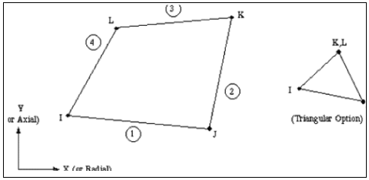
Fig. 2 Geometry of plane 55 element used in the thermal analysis

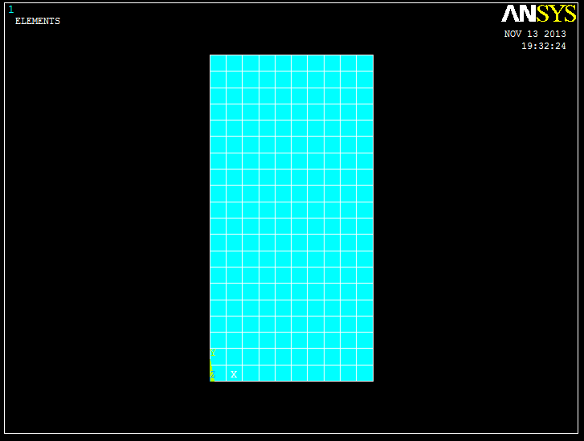
Fig. 3 Finite element mesh – beam 200 x 400mm
In thermal analysis, temperature is applied as convection on line. Two lateral sides and bottom side of the beam is exposed to ISO 834 standard fire. The beams were analysed by exposing two sides and bottom to the standard temperature curve specified in ISO 834 standard fire. Heat transfer from fire to element is by convection on line with a convection film coefficient of 25W/m²K. Load is applied in a number of load steps and each load step is again divided into number of sub steps. At time zero minute, uniform temperature of 20ºC is applied. The time - temperature curve is plotted for 20mm (Fig. 4) and 40mm (Fig. 5) lateral cover thickness. The dimension of the beam is 200 x 400mm. The fire resistance time is compared with data from IS 456 and the results from ANSYS thermal analysis. R30 represents the fire exposure time of 30minutes.

Fig. 4 Time-temperature curve of a beam 200 mm width -20mm lateral cover

Fig. 5 Time-temperature curve of a beam 200 mm width -40mm lateral cover
Table 1 gives a comparison of fire resistance ratings of IS 456: 2000 and ANSYS thermal analysis, which indicates good agreement between ANSYS and IS 456: 2000.
Table 1: Comparison of fire resistance of beam from IS 456 and ANSYS
Nominal cover (mm) | Width of beam (mm) | Fire resistance in hours as per IS 456: 2000 | Fire resistance in hours from ANSYS thermal analysis
20 | 200 | 1.5 | 1.5
40 | 200 | 2.0 | 2.15

4. Design Chart for Circular Column Of Diameter 250mm
Temperature profile of the column for 60 minutes ISO 834 standard fire exposure is as shown in figure 6. The fire exposure up to two hours time is analysed using software ANSYS. The time- temperature curve (Fig. 7) is plotted up to two hours time fire exposure.

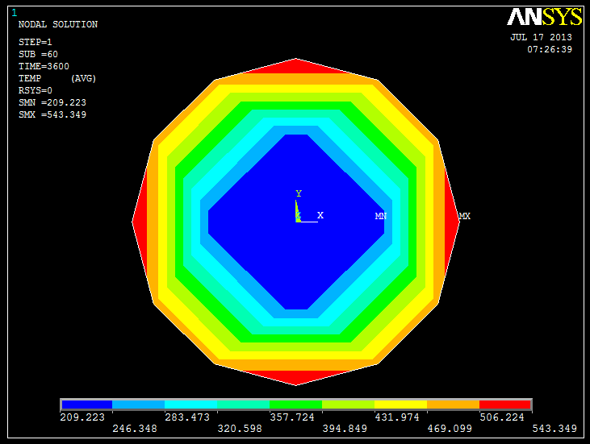
Fig. 6 Temperature profile for R60 fire exposure – circular column

Fig. 7 Time-Temperature curve of circular column
5. Conclusions
From the present study, the following conclusions were obtained
- The thermal response of concrete beams modelled in ANSYS is in good agreement with IS 456: 2000
- The prepared design chart makes further calculation of fire resistance less tedious
- The required cover thickness for a particular fire resistance time can be found out from the design charts.

6. Acknowledgements
The computer lab facility rendered by M. A. College of Engineering, Kothamangalam, Kerala, India.
References
[1] IS: 456, Indian Standard Plain and Reinforced Concrete - Code of Practice, (Bureau of Indian Standards, New Delhi, 2000)
[2] IS: 1642, Code of Practice for Fire Safety of Buildings (general): Details of Construction, (Bureau of Indian Standards, New Delhi, 1989).
[3] ISO 834, Fire resistance tests elements of building construction, (International Organization for Standardization, 1975)
[4] Buchanan A., Structural Design for Fire Safety, (Wiley and Sons, New York, 2002).

