**American Journal of Engineering Research (AJER)**

e-ISSN : 2320-0847 p-ISSN : 2320-0936

Volume-XX, Issue-XX, pp-XX-XX

www.ajer.org

Research Paper Open Access

**Finite element analysis and parametric study of**

**grid floor slab**

Muhammed Yoosaf.K.T 1, Ramadass S2, Jayasree Ramanujan 1

*1Mar Athanasius College of Engineering, Kothamangalam, Kerala*

*2Cochin University of Science and Technology, Kochi-22, Kerala*

**Received Manuscript: XX-XX-XXXX**

**Accept Manuscript: XX-XX-XXXX**

**Published Manuscript: XX-XX-XXXX**

***ABSTRACT  :*** *This paper deals with the influence of various parameters on the economical spacing of the transverse beams in grid floor. The parameters considered in this study are span to depth ratio, spacing of transverse beams, thickness of web and thickness of flange. The magnitude of span to depth ratio considered is 16 to 60. The spacing of transverse beams is varied from 0.5m to 2.0 m. Thickness of slab and the rib are made constant and are equal to 0.1m and 0.15m respectively. The bending moment, the shear force and the mid span deflection developed in grid floor beams have been predicted by conventional and numerical methods and the results are compared. The parametric study is carried out using the model proposed by ANSYS 12.0 software. The results of the study give an insight to the range for the magnitude of the various parameters to be considered for the optimum performance of grid floors.*

***Keywords  -*** *bending moments , deflection , grid , optimum , parameters , spacing.*

# **INTRODUCTION**

Grid floor system consisting of beams spaced at regular intervals in perpendicular directions and monolithic with slab are used for large rooms such as auditoriums, vestibules, theatre hall , show room shops etc., Different patterns of grid are possible namely, rectangular, square, diagonal , continuous etc.,[1]. Grids are found to be very efficient in load transferring. It is generally adopted when large column free space is required and reduces the span to depth ratio of rectangular grids. It leads to reduction in dead load due to voids and is suitable for longer spans with heavy loads. It also offers reduction in cost and exhibits good resistance to vibration. Grid floors can be analyzed by conventional methods namely Rankine-Grashoff’s method [2] and Timoshenko’s plate theory[3] The grid floors can also be analyzed by numerical methods. The grid floors system can also be analyzed using energy based approach, where the polynomial functions are used to model the mid span deflection and moments in the grids[4] A typical grid floor system is analysed by Muhammed [5]using MCAD(math computer aided design) program and compared the results with approximate methods and plate theory. Large deflection of plates, which are strengthened by parallel beams are analysed by Sapountzakis [6] using ANSYS software. Limited studies have been reported on the influence of various parameters on the economical spacing of the transverse beams in grid floor. In this paper, a typical grid floor of standard dimension adopted in practice has been considered. The bending moment, the shear force and the mid span deflection developed in grid floor system have been predicted by classical and numerical methods and the results are compared. The classical method proposed by Rankine-Grashoff and Timoshenko’s plate theory have been considered for the manual analysis. The numerical method proposed by ANSYS software has been considered for the computer analysis. The comparison is done to check the validity of the application of ANSYS software for the present parametric study. In this paper, the influence of various parameters, namely, span to depth ratio, spacing of transverse beams, thickness of web and thickness of flange on the bending moment, shear force and the mid span deflection developed of grid floor have been reported. The parametric study is carried out using ANSYS software.

# **ANALYTICAL MODEL**

**2.1** **Rankine – Grashoff’s method**

## The Rankine – Grashoff’s method is an approximate method which equates the deflection of ribs at junctions. A typical grid floor pattern is given in Fig.1.The spacing of ribs are given by a1 and b1 in the x and y directions respectively.

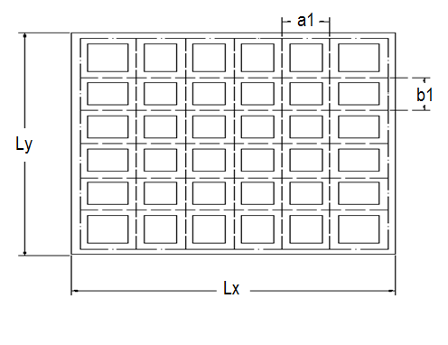

Fig.1. Grid floor pattern

## The deflections of ribs at junctions are made equal and is given by

 (1)

where, q1 and q2 are the loads shared in X and Y directions, respectively and is given by

  (2)

## where ,q is the total load the slab per unit area.

The bending moments for the central ribs are given by

  (3)

## **2.2 Timoshenko’s Plate theory:**

The vertical deflection at the middle is expressed as

 (4)

where q is the total uniformly distributed load per unit area. ax and by are the plate length in x and y directions respectively. Dx and Dy are the flexural rigidity per unit length of plate along x and y directions respectively. Cx and Cy are the torsional rigidity per unit length along x and y directions. If a1 and b1 are the spacing of ribs in x and y directions, then the relations are

 (5)

where EI1 and EI2 are the flexural rigidity and GC1 ,GC2 are the torsional rigidities. The bending moments, torsional moments and shears are computed using the following expressions.

 (6)

 (7)  (8)

 (9)

(10)



where Mx is the moment developed in the X direction and My is the moments developed in Y direction. The torsional moments( Mxy and Myx) are generated at the corners of the slab. Qx and Qy are the shear forces acting in X any Y direction respectively.

**2.3Analysis using ANSYS**

ANSYS is a UNIX or Windows program. In a UNIX environment it usually uses the X-Windows GUI (Graphical User Interface). ANSYS can be run interactively, but is usually run by providing input in the form of text file. ANSYS offers a comprehensive range of engineering simulation solution system providing access to virtually any field of engineering. For slab portion plate element SHELL 63 is used and for beam portion BEAM 188 element is utilized.

**2.3.1.Shell 63**

Shell 63 has been used as the element in the computer analysis. It has both bending and membrane capabilities. Both in-plane and normal loads are permitted. The element has six degrees of freedom at each node: translations in the nodal x, y, and z directions and rotations about the nodal x, y, and z-axes. Stress stiffening and large deflection capabilities are included. The geometry, node locations and the coordinate system for Shell 63 are given in Fig.2. The element is defined by four nodes, four thicknesses, elastic foundation stiffness, and the orthotropic material properties. Orthotropic material directions correspond to the element coordinate directions. The element coordinate system orientation is as described in coordinate Systems. The element x-axis may be rotated by an angle THETA (in degrees).The thickness is assumed to vary smoothly over the area of the element, with the thickness input at the four nodes. If the element has a constant thickness, only TK(I) need be input. If the thickness is not constant, all four thicknesses must be input.

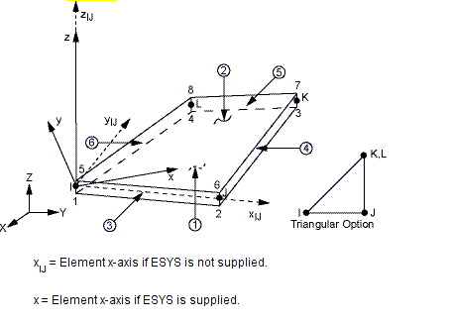

Fig.2.Geometry of Shell 63

**2.3.2 .Beam 188**

The grid floor beam is modeled using an element called BEAM 188 and is given in Fig 3. It is suitable for analyzing slender to moderately stubby or thick beam structures. The element is based on Timoshenko’s beam theory which includes shear-deformation effects. The element provides options for unrestrained warping and restrained warping of cross-sections. The element is a linear, quadratic, or cubic two-node beam element in 3-D. BEAM188 has six or seven degrees of freedom at each node. These include translations in the x, y, and z directions and rotations about the x, y, and z directions. A seventh degree of freedom (warping magnitude) is optional. This element is well-suited for linear, large rotation, and/or large strain nonlinear applications.

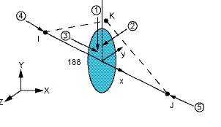

Fig.3.Geometry of Beam 188

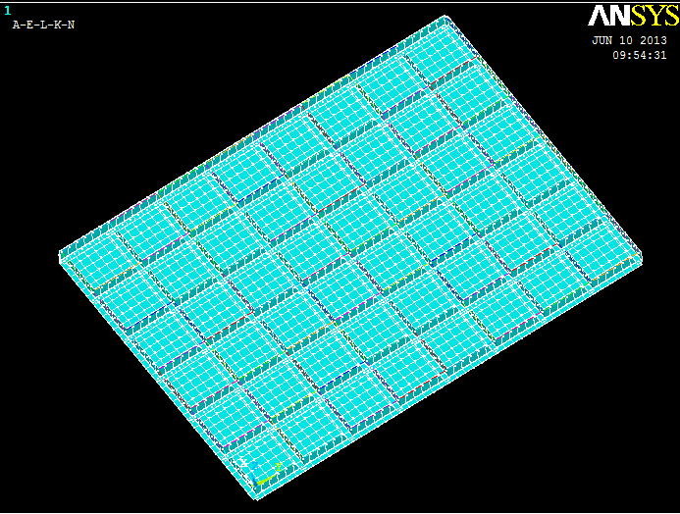 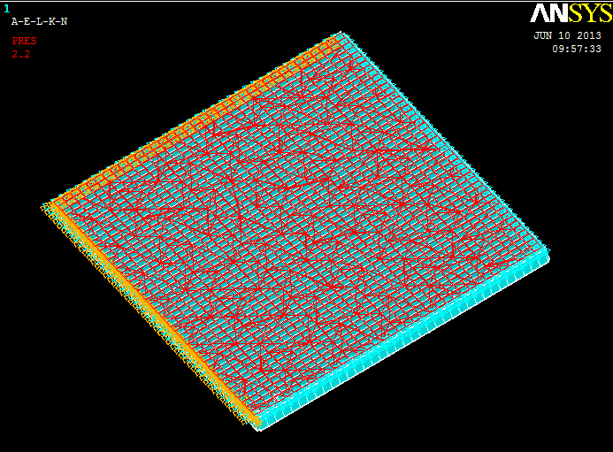

Fig.4.Bottom view of grid model Fig.5.Loaded structure with constraints

1. **DETAILS OF GRID FLOOR SYSTEM FOR THE ANALYSIS**

A typical grid floor system of standard dimensions adopted in practice has been considered. A rectangular grid floor of size 9m x 12m with centre to centre spacing of ribs at 1.5m in both ways having simply supported ends on two adjacent sides and fixed ends on the other two sides have been assumed. The thickness of the slab is assumed as 0.1m and the overall depth of the grid beam is assumed as 0.55m.The width of the grid beam is assumed as 0.15m. The live load on the floor is assumed as 1.5 kN/m2 as given in IS 875-part 2 (1987). The grade of concrete M20 and steel of grade Fe 415 are assumed. The maximum bending moments Mx and My developed at the centre of span, the maximum torsional moments Mxy and Myx developed at the ends of the grid and the shearing forces Qx and Qy developed at the supports are predicted using the models proposed by Rankine’s Grashoff method, Timoshenko’s plate theory and ANSYS software. The analysis using ANSYS is involved with meshing(repeating sentence). The meshed view of grid floor is given in Fig.4. The loaded structure with constraints is given in Fig.5. The predicted results obtained by the classical methods are compared with the corresponding analytical results obtained by the numerical method. The analytical results are given in Table 1. The results obtained by Rankine Grashoff theory is not in good agreement with the results obtained by numerical method. However the analytical results predicted by the numerical model is in good agreement with the analytical results predicted by the model proposed by Timoshenko’s plate theory. This indicates that the application of shell element 63 and the beam element 188 adopted in ANSYS software is valid for further parametric studies.

Table 1 Comparison of analytical results

|  |  |  |  |
| --- | --- | --- | --- |
| Maximum  values | Timoshenko’s plate theory | Rankines Grashoff theory | ANSYS 12.0 |
| Deflection | 7.33mm | 4mm | 7.4mm |
| Bending Moment Mx | 67.94 kNm | 83.87 kNm | 64.525kNm |
| Bending Moment My | 38.219kNm | 47.169kNm | 35.165kNm |
| Shear force Qx | 24.35kN | 37.27kN | 27.031 kN |
| Shear force Qy | 10.854kN | 15.723 kN | 7.71 kN |
| Torsional moments Mxy | 2.4307kNm | Not considered | 1.732kNm |

1. **PARAMETRIC STUDY**

The parametric study is carried out by assuming a typical rectangular grid floor given in Fig.1.The influence of various parameters namely span to depth ratio, spacing of transverse beams, thickness of web and thickness of flange on the bending moment, shear force and the mid span deflection developed on grid beams have been studied. The parametric study is carried out using ANSYS 12.0 software.

**4.1 Influence of spacing of grid beams on the mid span deflection response of grid floor beams for different span to depth ratios (L/D); keeping span (L) constant**

In this study a rectangular grid slab is assumed. The span of the grid beam in both X and Y direction Lx and Ly are made constant and is equal to 9m and 12m respectively. The depth of the grid beam (D) is varied from 0.55m to 0.15m. The spacing of grid beams is varied from 0.5m to 2.0 m. Hence the span to depth (L/D) ratio is varied from 16 to 60. Fig.6 shows the influence of spacing of grid beams on the mid span deflection response of grid floor beams for different span to depth ratios (L/D).

L/D

Fig.6.Spacing of grid Vs Mid span deflection

From Fig.6, it is found that when the spacing of grid beam increases, the mid span deflection also increases. The deflection is found to be more when the span to depth ratio (L/D) is increased to 60. The deflection is found to be depleting when the span to depth ratio (L/D) is reduced to 16.

**4.2Influence of spacing of grid beams on the moment Mx developed for different span to depth ratios (L/D); keeping span (L) constant**

The influence of spacing of grid beams on the bending moment Mx developed in grid beams for different span to depth ratios (L/D) is given in Fig.7. It is found that from Fig.7, when the spacing of grid beam increases bending moment Mx developed in the beams also increases. The bending moment Mx is found to be more when the span to depth ratio (L/D) is reduced to 16. The bending moment Mx developed in grid beams is found to be decreasing in nature when the span to depth ratio (L/D) is increased to 60.

Fig.7.Spacing of grid Vs Moment Mx

**4.3 Influence of spacing of grid beams on the moment My developed for different span to depth ratios (L/D) ; keeping span (L) constant**

Fig.8.Spacing of grid Vs Moment My

The influence of spacing of grid beams on the bending moment My developed in grid beams for different span to depth ratios (L/D) is given in Fig.8. It is found that from Fig.8, when the spacing of grid beam increases, the bending moment My developed in the beams also increases. The bending moment My is found to be increasing when the span to depth ratio (L/D) is reduced to 16. The bending moment My developed in grid beams is found to be decreasing, when the span to depth ratio (L/D) is increased to 60.

**4.4 Influence unit cost of grid floor on Spacing of grid beams different span to depth ratios (L/D) keeping span constant**

Fig.9. L/D ratio Vs Unit cost

|  |
| --- |
|  |

Fig. 10. Monogram indicating the cost implication of spacing ratio of grid beams

In this study, the influence of unit cost of grid floor on the spacing of grid beams for different span to depth ratios (L/D) is analysed. The span(L) of the beams are made constant and is equal to 9 m and 12 m in X and Y directions respectively. The cost of beam per unit length is taken as unit cost. The cost of grid beam per unit length is arrived by accounting the current Indian market rate for the materials, the cross section of beam and one metre length of grid beam. In the current Indian scenario, the present market rates for steel and concrete have been assumed. Cost of steel per kilogram is taken as 75 Indian rupees and the cost of 1m3 of concrete is taken as 10,000 Indian Rupees.

The unit cost in Indian rupees verses span to depth L/D ratios is given in Fig.9. The figure can be used as design aid for engineers for arriving at economical spacing of grid beams for the design of grid floor slabs.

#### **CONCLUSIONS**

Based on the present study, the following conclusions are arrived at.

* The spacing of grid beams influences the mid span deflection and the bending moments developed in the grid beams
* The span to depth ratio of grid floor slab system influences the mid span deflection and the bending moments developed in the grid floor beams

It is expected that the monogram developed in this study is useful for arriving at economical spacing of grid beams for the design of grid floor slabs.

floor slabs.

**Abbreviations**

Lx = Span of the grid floor in X direction,m

Ly = Span of the grid floor in Y direction,m

D = Overal depth of the grid beam ,m

E = Young’s modulus, N/mm2

I = Moment of inertia of the section considered, mm4

EI = Flexural rigidity,Nmm2

∆= Mid span deflection, mm

Mx = Moment in X direction,kNm

My = Moment in Y direction,kNm

Mxy = Torsional Moment in X direction,kNm

Myx = Torsional Moment in Y direction,kNm

Qx = Shear force in X direction, kN

Qy = Shear force in Y direction, kN

Cx = Torsional rigidities per unit length in x direction

Cy = Torsional rigidities per unit length in y direction

#### **REFERENCES**

#### [1] Krishna Raju N. Advanced reinforced concrete design (C.B.S Publishers and Distributers, New Delhi,2004).

#### [2]Varghese P. C. Advanced Reinforced Concrete Design (Prentice-Hall of India Private Limited, New Delhi2008),.

[3]Timoshenko, S. and Krieger, S.W) *Theory of Plates and shells* (2nd ed.,McGraw-Hill, NewYork, 1953),

[4]Amit A. Sathawane , R.S. Deotale(2002),"Analysis And Design of Flat Slab And Grid Slab And Their Cost Comparison, *International Journal of Engineering Research and Applications. (IJERA)**1(3,)* (2002),"*. ISSN: 2248-9622 pp837-848*

#### [5] Mohammed S. Al-Ansari, Teaching two-way ribbed slab analysis and design using the MathCAD program,5(3) (2006),, UNESCO ICEE).

#### [6] Sapountzakis E. J.,I.C. Dikaros (2011), Large deflection analysis of plates stiffened by parallel beams, Eng. Mech American Society of Civil Engineers., 138(8), (2011) 1021–1041..

#### [7]IS: 875 -Part II, Indian Standard Code of Practice for Design Loads (Other than earthquake) for Building and Structures, (1987) Bureau of Indian Standards, New Delhi.